Applecross Senior High School

Semester One Examination, 2019

Question/Answer booklet

MATHEMATICS

SOLUTIONS
SPECIALIST
UNIT 1

Section Two:

Calculator-assumed

Student number: In figures

In words

Your name

Time allowed for this section
Reading time before commencing work: ten minutes
Working time: one hundred minutes

Materials required/recommended for this section
To be provided by the supervisor
This Question/Answer booklet
Formula sheet (retained from Section One)

To be provided by the candidate
Standard items: pens (blue/black preferred), pencils (including coloured), sharpener,
correction fluid/tape, eraser, ruler, highlighters

Special items: drawing instruments, templates, notes on two unfolded sheets of A4 paper, and up to three calculators approved for use in this examination

Important note to candidates
No other items may be taken into the examination room. It is your responsibility to ensure that you do not have any unauthorised material. If you have any unauthorised material with you, hand it to the supervisor before reading any further.

Structure of this paper

Section | Number of questions available | Number of questions to be answered | Working  time (minutes) | Marks available | Percentage of examination
Section One:  Calculator-free | 8 | 8 | 50 | 52 | 35
Section Two:  Calculator-assumed | 13 | 13 | 100 | 98 | 65
 |  |  |  | Total | 100

Instructions to candidates

1. The rules for the conduct of examinations are detailed in the school handbook. Sitting this examination implies that you agree to abide by these rules.

2. Write your answers in this Question/Answer booklet preferably using a blue/black pen.
Do not use erasable or gel pens.

3. You must be careful to confine your answer to the specific question asked and to follow any instructions that are specified to a particular question.

4. Show all your working clearly. Your working should be in sufficient detail to allow your answers to be checked readily and for marks to be awarded for reasoning. Incorrect answers given without supporting reasoning cannot be allocated any marks. For any question or part question worth more than two marks, valid working or justification is required to receive full marks. If you repeat any question, ensure that you cancel the answer you do not wish to have marked.

5. It is recommended that you do not use pencil, except in diagrams.

6. Supplementary pages for planning/continuing your answers to questions are provided at the end of this Question/Answer booklet. If you use these pages to continue an answer, indicate at the original answer where the answer is continued, i.e. give the page number.

7. The Formula sheet is not to be handed in with your Question/Answer booklet.
Section Two: Calculator-assumed 65% (98 Marks)
This section has thirteen (13) questions. Answer all questions. Write your answers in the spaces provided.

Working time: 100 minutes.

Question 9 (5 marks)
In the diagram below, $M$ is the midpoint of $QR$.

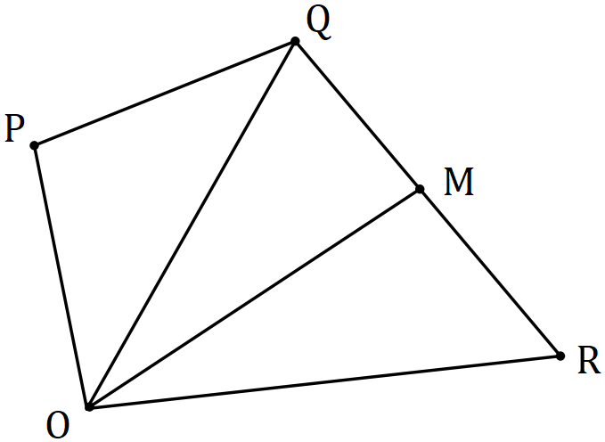

If $\vec{OP}=p, \vec{OQ}=q$ and $\vec{OR}=r$, express the following in terms of $p, q$ and $r$.

(a) $\vec{PR}$. (1 mark)
Solution
$$\vec{PR}=r-p$$

Specific behaviours
correct expression

(b) $\vec{OM}$. (2 marks)
Solution
$$\vec{OM}=\vec{OQ}+\frac{1}{2} \vec{QR} \\ =q+\frac{1}{2} (r-q) \\ =\frac{1}{2} q+\frac{1}{2} r$$

Specific behaviours
✓ indicates correct method
correct expression

Solution
$$\vec{MP}=\vec{MO}+\vec{OP}=p-\frac{1}{2} q-\frac{1}{2} r$$

$$\vec{MP}=6p-3q-3r$$

Specific behaviours
✓ indicates $\vec{MP}$
correct expression

(c) $6\vec{MP}$. (2 marks)

Question 10 (8 marks)
Points $P, Q$ and $R$ have coordinates $\left(-2, 11\right), (8, 15)$ and $(17, 3)$ respectively. Determine

(a) $\vec{PQ}$. (1 mark)
Solution
$$\vec{PQ}=\left(8, 15\right)-\left(-2, 11\right) \\ =\left(10, 4\right)$$

Specific behaviours
correct vector

(b) $|\vec{QR}|$. (2 marks)
Solution
$$\vec{QR}=\left(17, 3\right)-\left(8,15\right)$$
$$=\left(9, -12\right)$$

$$\left|\vec{QR}\right|=15$$

Specific behaviours
correct vector
magnitude

(c) $2\vec{PQ}-60u$, where $u$ is a unit vector in the direction $\vec{QR}$. (3 marks)
Solution
$$u=\frac{1}{15}(9, -12)$$

$$2\vec{PQ}-60u=2\left(10, 4\right)-\frac{60}{15}\left(9, -12\right) \\ =\left(-16, 56\right)$$

Specific behaviours
indicates unit vector
expression for result
correct vector

(d) The coordinates of point $S$, given that $\vec{RS}=\vec{QP}$. (2 marks)
Solution
$$\vec{OS}=\vec{OR}+\vec{RS} \\ =\vec{OR}-\vec{PQ} \\ =\left(21, 3\right)-(10, 4) \\ =(7, -1)$$

Specific behaviours
expression for result
correct coordinates

Question 11 (7 marks)
(a) In the diagram below (not drawn to scale) $A,B, C$ and $D$ lie on a circle and $EB$ and $ED$ are tangents to the circle. If $∠BED=54°$ and $∠CDB=20°$, determine the size of $∠CBD$.
(3 marks)
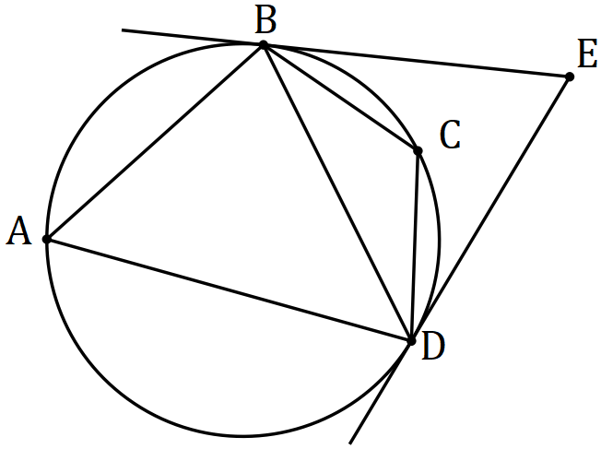
Solution
$$∠BDE=(180-54)÷2=63$$

$$∠CDE=63-20=43$$

$$∠CBD=∠CDE=43° (\text{AltSegment})$$

Specific behaviours
✓ $∠BDE$
$∠CDE$
✓ $∠CBD$

(b) Quadrilateral $ABCD$ is such that $CB=CD$, $∠BAD=96°$ and $∠BDC=48°$.

(i) Sketch a diagram to show this information. (1 mark)
Solution
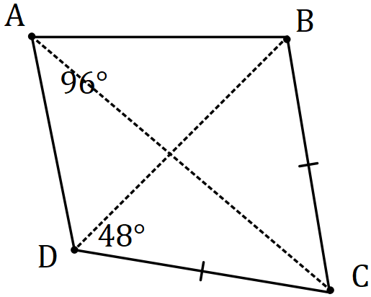
Specific behaviours
correct diagram

(ii) Show that $ABCD$ is cyclic and hence determine the size of $∠CAD$. (3 marks)
Solution
$$∠CBD=∠CDB=48$$
$$∠BCD=180-2×48=84$$

$$∠BAD+∠BCD=96+84=180$$
$$\text{Hence cyclic as opposite angles supplementary.}$$

$$∠CAD=∠CBD=48° \text{(Same arc)}$$

Specific behaviours
use isosceles triangle for $∠BCD$
✓ uses supplementary angles for cyclic
✓ correct size of $∠CAD$

Question 12 (8 marks)
(a) Show that the vectors $\left(8, -5\right)$ and $\left(2.5, 4\right)$ are perpendicular. (2 marks)
Solution
$$\left(\begin{matrix}8 \\ -5\end{matrix}\right)∙\left(\begin{matrix}2.5 \\ 4\end{matrix}\right)=20-20=0$$

Hence perpendicular as scalar (dot) product is $0$.

Specific behaviours
uses dot product
✓ explains result

(b) Determine, to the nearest degree, the angle between the vectors $\left(3, -2\right)$ and $\left(-2, -4\right)$.
(2 marks)
Solution
Using CAS: $θ=82.87≈83°$

Or: $θ=\cos^{-1}\left(\frac{2}{\sqrt{13}×2\sqrt{5}}\right)$

Specific behaviours
indicates method
✓ correct angle

(c) The vectors $\left(a, 2a+3\right)$ and $\left(a+3, -2\right)$ are perpendicular, where $a$ is a constant. Determine the value(s) of $a$ and the corresponding pair(s) of vectors. (4 marks)
Solution
$$\left(\begin{matrix}a \\ 2a+3\end{matrix}\right)∙\left(\begin{matrix}a+3 \\ -2\end{matrix}\right)=a^{2}+3a-4a-6=0$$

$$\left(a+2\right)\left(a-3\right)=0⇒a=-2, a=3$$

$$a=-2⇒\left(\begin{matrix}-2 \\ -1\end{matrix}\right) \text{and}\left(\begin{matrix}1 \\ -2\end{matrix}\right)$$

$$a=3⇒\left(\begin{matrix}3 \\ 9\end{matrix}\right) \text{and}\left(\begin{matrix}6 \\ -2\end{matrix}\right)$$

Specific behaviours
uses dot product to form equation
✓ solves equation
✓ states one pair of vectors
✓ states both pairs of vectors

Question 13 (8 marks)
(a) $A, B, C$ and $D$ lie on a circle with diameter $AC$ (diagram not to scale). Determine the size of $∠BDC$ when $∠BCA=25°$. (2 marks)

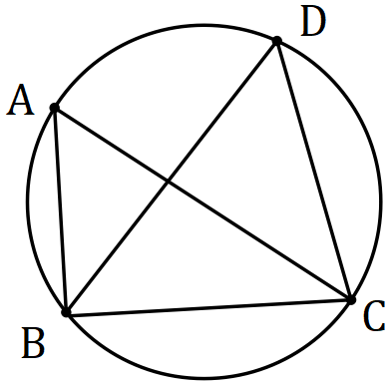
Solution
$$∠BAC=90-25=65$$

$$∠BAD=∠BAC=65°$$

Specific behaviours
uses angle in semi-circle for $∠BAC$
✓ correct value

(b) $K, L$ and $M$ lie on a circle (diagram not to scale). Secant $KN$ cuts the circle at $L$ and $JN$ is a tangent to the circle at $M$. Given that $∠LNM=37°$ and $∠LMN=48°$, determine the size of $∠MKL$ and the size of $∠KMJ$. (3 marks)
Solution
$$∠MKL=∠LMN=48° \text{(Alternate segments)}$$

$$∠KLM=37+48=85 \text{(Exterior angle)}$$

$$∠KMJ=∠KLM=85° \text{(Alternate segments)}$$

Specific behaviours
$∠MKL$
✓ $∠KLM$
✓ $∠KMJ$

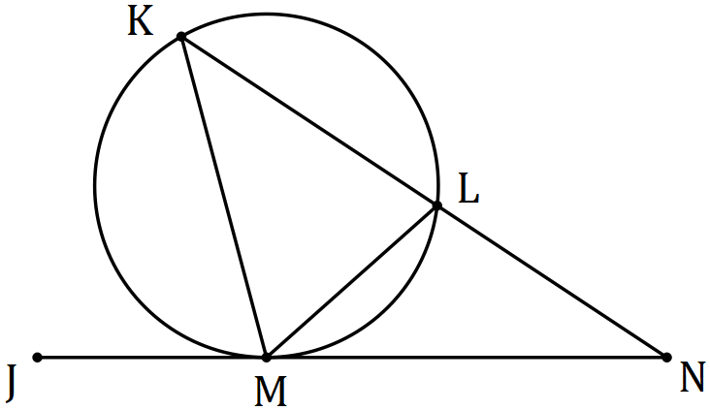

(c) $P, Q$ and $R$ lie on a circle of radius $85$ mm (diagram not to scale) and $PQ=PR=116$ mm. Determine the size of angle $∠QPR$, to the nearest degree. (3 marks)
Solution
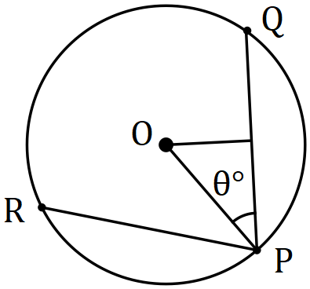
$$116÷2=58$$
$$θ=\cos^{-1}{\frac{58}{85}}=47.0°$$

$$∠QPR=2θ=94°$$

Specific behaviours
completes diagram
✓ uses trig ratio for half-angle
✓ correct angle

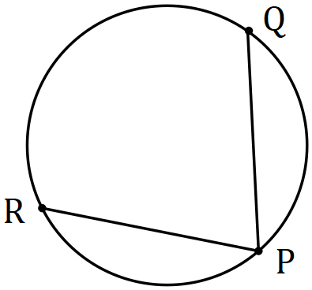

Question 14 (9 marks)
The parts of this question refer to the word AERIFICATION. It has $5$ different consonants and $7$ vowels, some of which are repeated.

(a) Determine the number of ways that $3$ different consonants chosen from the letters of the word can be arranged in a row. (1 mark)
Solution
$$^{5}P_{3}=60$$

Specific behaviours
correct number

(b) Determine the number of ways that all the letters of the word can be arranged in a row.
(2 marks)
Solution
$$\frac{12!}{3!×2!}=39 916 800$$

Specific behaviours
attempts to account for repeated letters
✓ correct number

(c) Determine the number of ways that all the letters of the word can be arranged in a row if the vowels must all be adjacent. (3 marks)
Solution
$$\frac{(5+1)!×7!}{3!×2!}=302 400$$

Specific behaviours
counts vowels as single group
✓ counts ways to arrange vowels
✓ correct number

(d) Determine how many $3$ letter permutations (e.g. TFI, IRI, etc) can be made using the letters of the word. (3 marks)
Solution
All different: $9×8×7=504$

Two A's and one other: $3×8=24$
Two I's and one other: $3×8=24$

Three I's: $1$

Total: $n=504+24+24+1=553$

Specific behaviours
attempts to consider separate cases
✓ correct number containing $2$ A's and $2$ I's
✓ correct total

Question 15 (8 marks)
(a) In the diagram below (not drawn to scale) $P, Q, R$ and $S$ lie on the circle with centre $O$. Determine the size of angles $α$, $β$ and $γ$ given that $∠PQR=105°$ and $2β=3γ$. (4 marks)

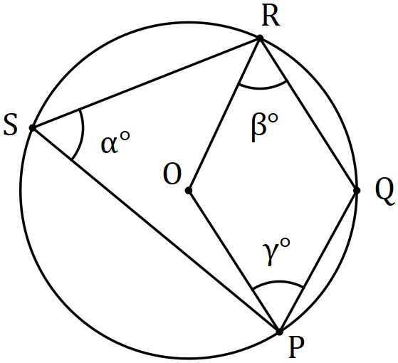
Solution
$$α=180-105=75°$$

$$β+γ=105 \\ 2β+2γ=210⇒5γ=210⇒γ=42°$$

$$β=63°$$

Specific behaviours
correct $α$
✓ equation for $β+γ$
correct $γ$
correct $β$

(b) Write the converse of the theorem that states the opposite angles of a cyclic quadrilateral are supplementary. (1 mark)
Solution
When opposite angles in a quadrilateral are supplementary, the quadrilateral is cyclic.

Specific behaviours
correct statement

(c) Prove by contradiction that the converse you wrote in (b) is true. Start by assuming that there is a quadrilateral that does have supplementary opposite angles but is not cyclic, such as $STUW$ shown below. (3 marks)

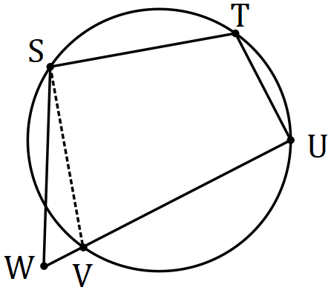
Solution
From assumption, $∠W=180°-∠T$.

But from regular theorem, $∠V=180°-∠T$.

Hence $∠W=∠V$, but this is impossible (as $SW$ and $SV$ would then be parallel and triangle $SVW$ would not exist). Thus, our original assumption must be wrong, and the converse must be true.

Specific behaviours
uses assumption
✓ develops contradiction
✓ explains contradiction and makes deduction

Question 16 (7 marks)
Three forces $a, b$ and $c$ act on a point in a plane.

The forces are$a=-44i+66j N$, $b=-12i-75j$ N and $c=180i+102j N$.

(a) Determine the magnitude of the resultant force and the direction, to the nearest degree, that the resultant makes with the vector $i$. (3 marks)
Solution
$$r=\left(\begin{matrix}-44 \\ 66\end{matrix}\right)+\left(\begin{matrix}-12 \\ -75\end{matrix}\right)+\left(\begin{matrix}180 \\ 102\end{matrix}\right)=\left(\begin{matrix}124 \\ 93\end{matrix}\right)$$

$$|r|=155 \text{N}$$

$$∠=36.9≈37°$$

Specific behaviours
resultant
✓ correct magnitude
✓ correct angle

When $λa+μb+c=0$, the forces are in equilibrium.

(b) Determine the values of the scalar constants $λ$ and $μ$ for equilibrium to occur. (4 marks)
Solution
$$λ\left(\begin{matrix}-44 \\ 66\end{matrix}\right)+μ\left(\begin{matrix}-12 \\ -75\end{matrix}\right)+\left(\begin{matrix}180 \\ 102\end{matrix}\right)=0$$

$$-44λ-12μ+180=0$$

$$66λ-75μ+102=0$$

$$λ=3, μ=4$$

Specific behaviours
✓ equation using $i$-coefficients
✓ equation using $j$-coefficients
✓ solves for $λ$
✓ solves for $μ$

Question 17 (8 marks)
(a) A set of cards is numbered from $100$ to $999$. Determine the minimum number of cards that must be selected to ensure that at least $3$ cards in the selection have the same last digit. Justify your answer using the pigeonhole principle. (3 marks)
Solution
Let pigeonholes be digits $0, 1, 2, …, 9$ and pigeons be the last digit of number on card.

Then fill all pigeonholes with $2$ pigeons, a total of $20$ pigeons.

The next pigeon will fill one of the pigeonholes with $3$ pigeons, and so the minimum number is $21$.

Specific behaviours
defines pigeons and pigeonholes
✓ clear explanation
✓ correct number

(b) Eight different books sit on a shelf, one of which has a hardcover and the rest softcovers. A student is told they can take away as many of them as they like but must not leave empty handed. Determine how many different selections can be made

(i) of exactly $3$ books. (1 mark)
Solution
$$\left(\begin{matrix}8 \\ 3\end{matrix}\right)=56$$

Specific behaviours
correct number

(ii) altogether. (2 marks)
Solution
Choose either $1, 2, …$ up to all $8$ books:

$$\sum_{n=1}^{8}{\left(\begin{matrix}8 \\ n\end{matrix}\right)}=2^{8}-1=255$$

Specific behaviours
uses property of Pascals triangle
✓ correct number

(iii) that include the hardcover. (2 marks)
Solution
Choose hardcover and then $0, 1, …$ up to $7$ others:

$$\left(\begin{matrix}1 \\ 1\end{matrix}\right)×\sum_{n=0}^{7}{\left(\begin{matrix}7 \\ n\end{matrix}\right)}=2^{7}=128$$

Specific behaviours
indicates method
✓ correct number

Question 18 (8 marks)
Relative to the origin, $A$ and $B$ have position vectors $18i+18j$ and $21i-15j$ respectively.

Particle $P$ is initially at $A$ and moves with a constant velocity of $8i-15j$ ms⁻¹.

(a) Calculate
Solution
$$s=\sqrt{8^{2}+{(-15)}^{2}}=17 \text{m/s}$$

Specific behaviours
correct speed

(i) the speed of $P$. (1 mark)

(ii) the position vector of $P$ after $4$ seconds. (1 mark)
Solution
$$\left(\begin{matrix}18 \\ 18\end{matrix}\right)+4\left(\begin{matrix}8 \\ -15\end{matrix}\right)=\left(\begin{matrix}50 \\ -42\end{matrix}\right)$$

Specific behaviours
correct position

(iii) the distance of$P$ from $B$ after $4$ seconds. (2 marks)
Solution
$$\vec{PB}=\left(\begin{matrix}21 \\ -15\end{matrix}\right)-\left(\begin{matrix}50 \\ -42\end{matrix}\right)=\left(\begin{matrix}-29 \\ 27\end{matrix}\right)$$

$$\left|\vec{PB}\right|=\sqrt{{\left(-29\right)}^{2}+{\left(27\right)}^{2}}=\sqrt{1570}≈39.6 \text{m}$$

Specific behaviours
vector $\vec{PB}$
✓ correct distance

(b) Determine how long after leaving $A$ that $P$ is $157$ m from $B$. (4 marks)
Solution
$$\vec{OP}=\left(\begin{matrix}18 \\ 18\end{matrix}\right)+t\left(\begin{matrix}8 \\ -15\end{matrix}\right)$$

$$\vec{PB}=\left(\begin{matrix}21 \\ -15\end{matrix}\right)-\left(\begin{matrix}18+8t \\ 18-15t\end{matrix}\right)$$

$$|{\vec{PB}\left.​\right|}^{2}={\left(3-8t\right)}^{2}+{\left(-33+15t\right)}^{2}={157}^{2}$$

$$t=11$$

Specific behaviours
expression for $\vec{OP}$
✓ expression for $\vec{PB}$
✓ equation using distance
✓ correct time

Question 19 (7 marks)

$ABCD$ is a trapezium with $\vec{AB}$ parallel and in the same direction to $\vec{DC}$.

(a) Sketch a labelled diagram of $ABCD$. (1 mark)
Solution
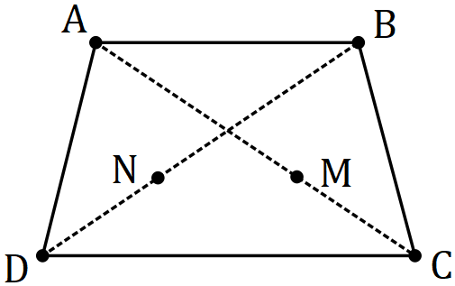
Specific behaviours
correct diagram

(b) Show that $\vec{AC}+\vec{DB}=\vec{AB}+\vec{DC}$. (2 marks)
Solution
$$\vec{AC}+\vec{DB}=\left(\vec{AB}+\vec{BC}\right)+\left(\vec{DA}+\vec{AB}\right) \\ =\vec{AB}+\left(\vec{DA}+\vec{AB}+\vec{BC}\right) \\ =\vec{AB}+\vec{DC}$$

Specific behaviours
splits $\vec{AC}$ and $\vec{DB}$
✓ groups vectors that make $\vec{DC}$

(c) $M$ lies on $AC$ and $N$ lies on $BD$ so that $AM:MC=BN:ND=2:1$. Use a vector method to prove that $ABNM$ is a trapezium. (4 marks)
Solution
$$\vec{AM}=\frac{2}{3}\vec{AC}, \vec{AN}=\vec{AB}+\frac{2}{3}\vec{BD}$$

$$\vec{NM}=\vec{AM}-\vec{AN} \\ =\frac{2}{3}\vec{AC}-\left(\vec{AB}+\frac{2}{3}\vec{BD}\right) \\ =\frac{2}{3}\left(\vec{AC}-\vec{BD}\right)-\vec{AB} \\ =\frac{2}{3}\left(\vec{AC}+\vec{DB}\right)-\vec{AB} \\ =\frac{2}{3}\left(\vec{AB}+\vec{DC}\right)-\vec{AB} \text{[from (b)]}$$

$$\text{But} \vec{DC}=k\vec{AB}$$

$$\vec{NM}=\frac{2}{3}\left(\vec{AB}+k\vec{AB}\right)-\vec{AB} \\ =\left(\frac{2k-1}{3}\right)\vec{AB}⇒ABNM \text{is trapezium}$$

Specific behaviours
vectors for $M$ and $N$
✓ obtains $\vec{NM}$ without $M$ and $N$
✓ obtains $\vec{NM}$ in terms of $\vec{AB}, \vec{DC}$
✓ obtains $\vec{NM}$ in terms of $\vec{AB}$

Question 20 (7 marks)
Farm $A$ lies $95$ km away from farm $B$ on a bearing of $062°$. A helicopter leaves farm $A$ at $7:30$ am to fly to farm $B$. The helicopter can maintain a speed of $145$ kmh⁻¹ and there is a steady wind of $35$ kmh⁻¹ blowing from the north.

Determine the bearing that the helicopter should steer and the time of its arrival at farm $B$, to the nearest minute.
Solution
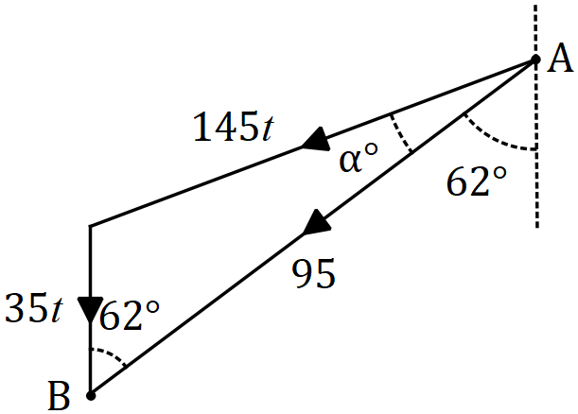

$$\frac{\sin{62}}{145t}=\frac{\sin{α}}{35t}$$

$$α=12.3°$$

$$\text{Bearing: }180+62+12.3=254.3°$$

$$180-62-12.3=105.7$$

$$\frac{\sin{62}}{145t}=\frac{\sin{105.7}}{95}$$

$$t=0.601 \text{h} \\ =36 \text{m}$$

$$\text{Arrive at} 8:06 \text{am}$$

Specific behaviours
diagram showing vectors and resultant
equation using sin rule for $α$
✓ value of $α$
correct bearing
equation using sin rule for $t$
✓ value of $t$
correct arrival time

Question 21 (8 marks)
Determine how many of the integers between $1$ and $340$ inclusive are

(a) divisible by $6$. (1 mark)
Solution
$$\left\lfloor 340÷6\right\rfloor =56 \\ n=56$$

Specific behaviours
correct number

(b) divisible by $6$ or $7$. (3 marks)
Solution
LCM: $\left(6,7\right)=42;$

$$\left\lfloor 340÷7\right\rfloor =48 \\ \left\lfloor 340÷42\right\rfloor =8$$

$$n=56+48-8=96$$

Specific behaviours
number divisible by $42$
✓ indicates use of inclusion-exclusion
correct number

(c) divisible by $6$ or $7$ but not both. (1 mark)

Solution
$$n=96-8=88$$

Specific behaviours
correct number

(d) divisible by $6$ or $7$ but not $4$. (3 marks)
Solution
LCM's: $\left(6, 4\right)=12; \left(7, 4\right)=28; \left(4, 6, 7\right)=84$

$$\left\lfloor 340÷12\right\rfloor =28 \\ \left\lfloor 340÷28\right\rfloor =12 \\ \left\lfloor 340÷84\right\rfloor =4$$

$$n=96-28-12+4=60$$

Specific behaviours
✓ divisible by $12, 28$
✓ divisible by $84$
correct number

Supplementary page

Question number: _________

Supplementary page

Question number: _________

Supplementary page

Question number: _________

Supplementary page

Question number: _________

© 2019 WA Exam Papers. Applecross Senior High School has a non-exclusive licence to copy and communicate this document for non-commercial, educational use within the school. No other copying, communication or use is permitted without the express written permission of WA Exam Papers. SN002-131-4.

