Applecross Senior High School

Semester One Examination, 2020

Question/Answer booklet

MATHEMATICS

SOLUTIONS
SPECIALIST
UNIT 1

Section One:

Calculator-free

WA student number: In figures

In words

Your name

Number of additional
answer booklets used
(if applicable):

Time allowed for this section
Reading time before commencing work: five minutes
Working time: fifty minutes

Materials required/recommended for this section
To be provided by the supervisor
This Question/Answer booklet
Formula sheet

To be provided by the candidate
Standard items: pens (blue/black preferred), pencils (including coloured), sharpener,
correction fluid/tape, eraser, ruler, highlighters

Special items: nil

Important note to candidates
No other items may be taken into the examination room. It is your responsibility to ensure that you do not have any unauthorised material. If you have any unauthorised material with you, hand it to the supervisor before reading any further.

Structure of this paper

Section | Number of  questions  available | Number of  questions to  be answered | Working  time  (minutes) | Marks  available | Percentage  of  examination
Section One:  Calculator-free | 8 | 8 | 50 | 52 | 35
Section Two:  Calculator-assumed | 13 | 13 | 100 | 98 | 65
 |  |  |  | Total | 100

Instructions to candidates

1. The rules for the conduct of examinations are detailed in the school handbook. Sitting this examination implies that you agree to abide by these rules.

2. Write your answers in this Question/Answer booklet preferably using a blue/black pen.
Do not use erasable or gel pens.

3. You must be careful to confine your answers to the specific question asked and to follow any instructions that are specific to a particular question.

4. Show all your working clearly. Your working should be in sufficient detail to allow your answers to be checked readily and for marks to be awarded for reasoning. Incorrect answers given without supporting reasoning cannot be allocated any marks. For any question or part question worth more than two marks, valid working or justification is required to receive full marks. If you repeat any question, ensure that you cancel the answer you do not wish to have marked.

5. It is recommended that you do not use pencil, except in diagrams.

6. Supplementary pages for planning/continuing your answers to questions are provided at the end of this Question/Answer booklet. If you use these pages to continue an answer, indicate at the original answer where the answer is continued, i.e. give the page number.

7. The Formula sheet is not to be handed in with your Question/Answer booklet.
Section One: Calculator-free 35% (52 Marks)
This section has eight questions. Answer all questions. Write your answers in the spaces provided.

Working time: 50 minutes.

Question 1 (3 marks)
Two vectors $\tilde{a}$ and $\tilde{b}$ have magnitudes $3$ and $\sqrt{3}$ respectively. The angle between the two vectors is measured at $30°$. Find the magnitude of the resultant of the two vectors.

Solution
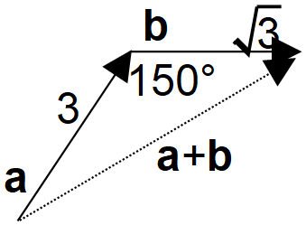
$$r^{2}=3^{2}+{\sqrt{3}}^{2}-2×3×\sqrt{3}\cos{150°}$$
$$r^{2}=9+3-6\sqrt{3}\frac{-\sqrt{3}}{2}$$
$$r^{2}=21$$
$$r=\sqrt{21}$$

Specific behaviours
correct sketch of the situation with new angle size and resultant
cosine rule to find vector $\tilde{a}+\tilde{b}$
magnitude of $\tilde{a}+\tilde{b}$

Question 2 (7 marks)
Two forces are given by $F_{1}=-3i+5j$ N and $F_{2}=2i-j$ N.

(a) Determine

(i) $F_{1}-F_{2}$. (1 mark)
Solution
$$\left(\begin{matrix}-3 \\ 5\end{matrix}\right)-\left(\begin{matrix}2 \\ -1\end{matrix}\right)=\left(\begin{matrix}-5 \\ 6\end{matrix}\right) \text{N}$$

Specific behaviours
correct vector

(ii) $5F_{1}+10F_{2}$. (2 marks)
Solution
$$5\left(\begin{matrix}-3 \\ 5\end{matrix}\right)+10\left(\begin{matrix}2 \\ -1\end{matrix}\right)=\left(\begin{matrix}-15 \\ 25\end{matrix}\right)+\left(\begin{matrix}20 \\ -10\end{matrix}\right)=\left(\begin{matrix}5 \\ 15\end{matrix}\right) \text{N}$$

Specific behaviours
one correct multiple
correct vector

(iii) $|F_{1}|$. (1 mark)
Solution
$$\left|\left(\begin{matrix}-3 \\ 5\end{matrix}\right)\right|=\sqrt{{\left(-3\right)}^{2}+5^{2}}=\sqrt{34} \text{N}$$

Specific behaviours
correct value

(b) The resultant of $3F_{1}$, $6F_{2}$ and a third force is $5i+4j$ N. Determine the magnitude of the third force. (3 marks)
Solution
$$F_{3}=\left(\begin{matrix}5 \\ 4\end{matrix}\right)-\left(\begin{matrix}-9 \\ 15\end{matrix}\right)-\left(\begin{matrix}12 \\ -6\end{matrix}\right) \\ =\left(\begin{matrix}2 \\ -5\end{matrix}\right)$$

$$|F_{3}|=\sqrt{4+25}=\sqrt{29}$$

Specific behaviours
✓ correct vector equation
✓ correct third force
correct magnitude

Question 3 (8 marks)
(a) Consider the statement: $n=2⇒n^{2}=4$.

(i) Write the inverse statement. (1 mark)
Solution
$$n≠2⇒n^{2}≠4$$

Specific behaviours
correct statement

(ii) Write the converse statement. (1 mark)
Solution
$$n^{2}=4⇒n=2$$

Specific behaviours
correct statement

(b) State whether each of the following statements are true or false, supporting each answer with an example or counterexample.

(i) $∀$ positive integer $x, \sqrt{x}≤x$. (2 marks)
Solution
True.

If $x=1, \sqrt{x}=1$ and $1≤1$.

Specific behaviours
states true, with counterexample
✓ counterexample using positive integer

(ii) $∀a∈R, ∃b∈R$ such that $ab=24$. (2 marks)
Solution
False.

If $a=0$ then no value for $b$ exists so that $ab=24$.

Specific behaviours
states false, with counterexample
✓ counterexample with $a=0$

(c) If a true statement is negated, explain whether the contrapositive of the negated statement will also be true.
Solution
No. If a statement is true then the contrapositive will always be true and if a true statement is negated, the negated statement will always be false.

Specific behaviours
states no, explaining truth of negated statement
✓ explains truth of contrapositive statement
(2 marks)

Question 4 (6 marks)
The position vectors of points $A$ and $B$ are $r_{A}=\left(\begin{matrix}-8 \\ 3\end{matrix}\right)$ and $r_{B}=\left(\begin{matrix}7 \\ -2\end{matrix}\right)$.

(a) Determine the position vector of point $P$ that divides $AB$ internally in the ratio $2:3$.
(3 marks)
Solution
$$\vec{AB}=\left(\begin{matrix}7 \\ -2\end{matrix}\right)-\left(\begin{matrix}-8 \\ 3\end{matrix}\right)=\left(\begin{matrix}15 \\ -5\end{matrix}\right)$$

$$P=A+\frac{2}{5}\vec{AB} \\ =\left(\begin{matrix}-8 \\ 3\end{matrix}\right)+\frac{2}{5}\left(\begin{matrix}15 \\ -5\end{matrix}\right) \\ =\left(\begin{matrix}-2 \\ 1\end{matrix}\right)$$

Specific behaviours
vector $\vec{AB}$
✓ indicates appropriate method
✓ correct position vector

(b) A small body leaves $A$ and moves with a constant velocity in a direction parallel to $\left(\begin{matrix}2 \\ 1\end{matrix}\right)$. Determine, with reasons, whether the body will pass through point $C$ with position vector $r_{C}=\left(\begin{matrix}6 \\ 9\end{matrix}\right)$. (3 marks)
Solution
$$\vec{AC}=\left(\begin{matrix}6 \\ 9\end{matrix}\right)-\left(\begin{matrix}-8 \\ 3\end{matrix}\right)=\left(\begin{matrix}14 \\ 6\end{matrix}\right)$$

But $\left(\begin{matrix}14 \\ 6\end{matrix}\right)≠k\left(\begin{matrix}2 \\ 1\end{matrix}\right)$ and so body will not pass through $C$ as $\vec{AC}$ is not parallel to $\left(\begin{matrix}2 \\ 1\end{matrix}\right)$.

Specific behaviours
vector $\vec{AC}$
✓ indicates $\vec{AC}$ not parallel to velocity
✓ states will not pass through $C$

Question 5 (7 marks)
(a) $4$ different letters are chosen from the $7$ in the word PAYMENT and then arranged to form a password. Determine how many different passwords are possible that

(i) end in T. (1 mark)
Solution
$$n\left(---T\right)=6×5×4×1=120$$

Specific behaviours
correct number

(ii) end in T or start with P. (3 marks)
Solution
$$n\left(P---\right)=120$$

$$n\left(P--T\right)=1×5×4×1=20$$

$$n=120+120-20=220$$

Specific behaviours
number for P and T
✓ uses inclusion-exclusion principal
correct number

(b) Determine the number of two letter permutations that can be made using letters from the word REPAYMENT. (3 marks)
Solution
$8$ letters - $7$ singles and $1$ double (E).

Both different: $8×7=56$

Both the same: $1×1=1$

Total permutations: $56+1=57$.

Specific behaviours
breaks into exclusive cases
✓ correct calculation for each case
✓ correct number

Question 6 (7 marks)
Trapezium $OABC$ is such that $\vec{AB}=3\vec{OC}$.

The midpoints of sides $OA, AB, BC$ and $OC$ are $P,Q, R$ and $S$.

Let $\vec{OA}=a$ and $\vec{OC}=c$. Use a vector method to prove that $PQRS$ is a parallelogram.
Solution
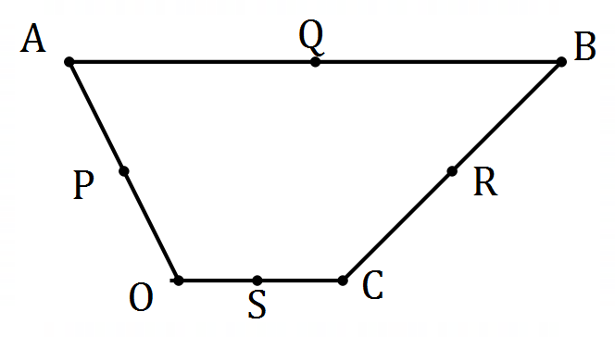

Then $\vec{OP}=\frac{1}{2}a$, $\vec{OQ}=a+\frac{3}{2}c$.
Hence $\vec{PQ}=\vec{OQ}-\vec{OP}=a+\frac{3}{2}c-\frac{1}{2}a=\frac{1}{2}a+\frac{3}{2}c$.

Note that $\vec{CB}=-c+a+3c=a+2c$.

Also $\vec{OS}=\frac{1}{2}c,$ $\vec{OR}=c+\frac{1}{2}\left(a+2c\right)=\frac{1}{2}a+2c$.
Hence $\vec{SR}=\vec{OR}-\vec{OS}=\frac{1}{2}a+2c-\frac{1}{2}c=\frac{1}{2}a+\frac{3}{2}c$.

Hence $PQRS$ is a parallelogram as $\vec{PQ}=\vec{SR}$(has a pair of equal length, parallel sides).

Specific behaviours
diagram of trapezium, roughly to scale
✓ uses correct vector notation throughout
✓ vectors $\vec{OP}$, $\vec{OQ}$
✓ vector $\vec{PQ}$
✓ vectors $\vec{OS}$, $\vec{OR}$
✓ vector $\vec{SR}$
✓ conclusion

Question 7 (7 marks)
Consider the vectors $p=\left(\begin{matrix}-7 \\ 8\end{matrix}\right), q=\left(\begin{matrix}3 \\ -4\end{matrix}\right)$ and $r=\left(\begin{matrix}1 \\ -2\end{matrix}\right)$.

(a) Determine the vector projection of $r$ onto $q$. (3 marks)
Solution
$$\hat{q}=\frac{1}{5}\left(\begin{matrix}3 \\ -4\end{matrix}\right)$$

$$\frac{1}{5}\left(\begin{matrix}3 \\ -4\end{matrix}\right)⋅\left(\begin{matrix}1 \\ -2\end{matrix}\right)=\frac{11}{5}$$

Hence required vector is
$$\frac{11}{5}×\frac{1}{5}\left(\begin{matrix}3 \\ -4\end{matrix}\right)=\left(\begin{matrix}{33}/{25} \\ {-44}/{25}\end{matrix}\right)$$

Specific behaviours
unit vector for $q$
✓ scalar product
✓ correct vector

(b) Given that $p=λq+μr$, determine the value of $λ$ and the value of $μ$. (4 marks)
Solution
$$λ\left(\begin{matrix}3 \\ -4\end{matrix}\right)+μ\left(\begin{matrix}1 \\ -2\end{matrix}\right)=\left(\begin{matrix}-7 \\ 8\end{matrix}\right)$$

Equating $i$ and $j$ coefficients:
$$3λ+μ=-7 \\ -4λ-2μ=8$$
Hence
$$6λ+2μ=-14 \\ -4λ-2μ=8$$

$$2λ=-6⇒λ=-3 \\ μ=-7-3\left(-3\right)=2$$

$$λ=-3, μ=2$$

Specific behaviours
equation using $i$-coefficients
equation using $j$-coefficients
✓ value of $λ$
✓ value of $μ$

Question 8 (7 marks)
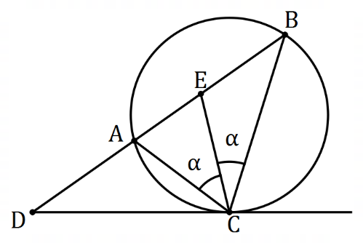
In the diagram shown, $A, B$ and $C$ lie on a circle.
The tangent at $C$ and secant $BA$ intersect at $D$.
Point $E$ lies on $AB$ so that $CE$ bisects $∠ACB$.

(a) Show that $∠DEC=∠DCE$. (3 marks)
Solution
Given $∠ACE=∠BCE=α$.

Let $∠ACD=β$, so that $∠DCE=α+β$.

$∠CBE=∠ACD=β$ (alternate segment)

$∠DEC=α+β$ (sum of opposite interior angles)

Hence $∠DEC=∠DCE$ as required.
Specific behaviours
uses alternate segment theorem
✓ uses triangle properties
✓ logical explanation

(b) Given that $AE=4$ cm and $BE=9$ cm, determine the length of $DC$. (4 marks)
Solution
$DC^{2}=DA×DB$ (intersecting secants)

Let $DC=DE=x$ (isosceles triangle) so that $DA=x-4$ and $DB=x+9$.
Then
$$x^{2}=\left(x-4\right)\left(x+9\right) \\ x^{2}=x^{2}+5x-36 \\ 5x=36 \\ x=\frac{36}{5} \text{cm} (=7.2)$$

Specific behaviours
uses intersecting secants theorem
✓ uses isosceles triangles to express required lengths
✓ forms equation
✓ correct length

Supplementary page

Question number: _________

© 2020 WA Exam Papers. Applecross Senior High School has a non-exclusive licence to copy and communicate this document for non-commercial, educational use within the school. No other copying, communication or use is permitted without the express written permission of WA Exam Papers. SN002-151-3.

