Semester One Examination, 2017

Question/Answer booklet

MATHEMATICS

SOLUTIONS
SPECIALIST
UNIT 1

Section One:

Calculator-free

Student Number: In figures

In words

Your name

Time allowed for this section
Reading time before commencing work: five minutes
Working time: fifty minutes

Materials required/recommended for this section
To be provided by the supervisor
This Question/Answer booklet
Formula sheet

To be provided by the candidate
Standard items: pens (blue/black preferred), pencils (including coloured), sharpener, correction fluid/tape, eraser, ruler, highlighters

Special items: nil

Important note to candidates
No other items may be taken into the examination room. It is your responsibility to ensure that you do not have any unauthorised material. If you have any unauthorised material with you, hand it to the supervisor before reading any further.

Structure of this paper

Section | Number of questions available | Number of questions to be answered | Working  time (minutes) | Marks available | Percentage of examination
Section One:  Calculator-free | 6 | 6 | 50 | 52 | 35
Section Two:  Calculator-assumed | 12 | 12 | 100 | 96 | 65
 |  |  |  | Total | 100

Instructions to candidates

1. The rules for the conduct of examinations are detailed in the school handbook. Sitting this examination implies that you agree to abide by these rules.

2. Write your answers in this Question/Answer booklet.

3. You must be careful to confine your response to the specific question asked and to follow any instructions that are specified to a particular question.

4. Additional working space pages at the end of this Question/Answer booklet are for planning or continuing an answer. If you use these pages, indicate at the original answer, the page number it is planned/continued on and write the question number being planned/continued on the additional working space page.

5. Show all your working clearly. Your working should be in sufficient detail to allow your answers to be checked readily and for marks to be awarded for reasoning. Incorrect answers given without supporting reasoning cannot be allocated any marks. For any question or part question worth more than two marks, valid working or justification is required to receive full marks. If you repeat any question, ensure that you cancel the answer you do not wish to have marked.

6. It is recommended that you do not use pencil, except in diagrams.

7. The Formula sheet is not to be handed in with your Question/Answer booklet.

Section One: Calculator-free 35% (52 Marks)
This section has six (6) questions. Answer all questions. Write your answers in the spaces provided.

Working time: 50 minutes.

Question 1 (7 marks)
It can be shown that for all $n≥0,$
$$^{n+1}P_{r}=\frac{n+1}{n-r+1}×{ ^{n}P}_{r}$$

(a) Show that the identity is true when $n=4$ and $r=2$. (2 marks)
Solution
$$LHS= ^{5}P_{2}=\frac{5×4×3×2×1}{3×2×1}=20$$

$$RHS=\frac{5}{3}× ^{4}P_{2}=\frac{5}{3}×\frac{4×3×2×1}{2×1}=20$$

Specific behaviours
evaluates LHS
evaluates RHS

Given that $^{8}P_{4}=1 680$, $^{12}P_{5}=95 040$ and $^{12}P_{6}=665 280$, evaluate

(b) $^{11}P_{6}$. (2 marks)
Solution
$$^{12}P_{6}=\frac{12}{6}× ^{11}P_{6} \\ ^{11}P_{6}=\frac{665280}{2}=332 640$$

Specific behaviours
relates $^{12}P_{6}$ and $^{11}P_{6}$
evaluates

(c) $^{10}P_{4}$. (3 marks)
Solution
$$^{10}P_{4}=\frac{10}{6}× ^{9}P_{4} \\ =\frac{10}{6}×\frac{9}{5}× ^{8}P_{4} \\ =3×1680=5040$$

Specific behaviours
expresses in terms of $^{9}P_{4}$
expresses in terms of $^{8}P_{4}$
evaluates

Question 2 (11 marks)
Three vectors are given by $a=3i-5j$, $b=-2i+7j$ and $c=6i+j$.

(a) Determine

(i) $a+b+c$. (1 mark)
Solution
$$a+b+c=7i+3j$$

Specific behaviours
states vector

(ii) $|c|$. (1 mark)
Solution
$$\left|c\right|=\sqrt{36+1}=\sqrt{37}$$

Specific behaviours
states exact value

(iii) $2a+3b$. (2 marks)
Solution
$$2a=6i-10j$$
$$3b=-6i+21j$$

$$2a+3b=11j$$
Specific behaviours
determines scalar multiples
determines sum

(b) Determine the unit vector $\hat{d}$ that is parallel and in the same direction as $b-a$. (3 marks)
Solution
$$d=b-a=-5i+12j$$

$$\left|b-a\right|=13$$

$$\hat{d}=-\frac{5}{13}i+\frac{12}{13}j$$

Specific behaviours
determines $b-a$
determines magnitude
states unit vector

(c) Express $c$ in terms of $a$ and $b$. (4 marks)
Solution
$$\text{Let} c=xa+yb$$

$$i\text{-coeffs}:3x-2y=6$$
$$j\text{-coeffs}: -5x+7y=1$$

$$15x-10y=30$$
$$-15x+21y=3$$
$$11y=33⇒y=3$$
$$x=4$$

$$c=4a+3b$$

Specific behaviours
equates $i$-coeffs
equates $j$-coeffs
solves equations for first variable
solves equations for second variable and states $c$

Question 3 (8 marks)
(a) Write the inverse of the following true statement and comment on the truth of the inverse statement. (2 marks)

"If the discriminant of the quadratic formula is zero, then the quadratic has just one real root."
Solution
If the discriminant of the quadratic formula is not zero, then the quadratic does not have just one real root.

Statement is true.

Specific behaviours
changes 'if P then Q' to 'if not P then not Q'
indicates statement is true

(b) Write the converse of the following true statement and comment on the truth of the converse statement. (2 marks)
"If $x>3$ then $x>2$."
Solution
If $x>2$ then $x>3$.

Statement is false.

Specific behaviours
changes 'if P then Q' to 'if Q then P'
indicates statement is false

(c) Determine the truth of the following statements, using an example or counter-example to support each answer.

(i) If $z∈R$ and $z^{3}$ is an even number then $z$ is an even number. (2 marks)
Solution
Statement is false.
If $z^{3}=6$ (even) then $z=\sqrt[3]{6}$ (irrational, not even).

Specific behaviours
states false
supplies counter-example

(ii) If $x,y∈Z$ and $x>y$ then $x^{2}>y^{2}$. (2 marks)
Solution
Statement is false.
If $x=2, y=-3$ then $2>-3$ but $2^{2}≯{(-3)}^{2}$.

Specific behaviours
states false
supplies counter-example using integers

Question 4 (7 marks)
(a) A body moves from $P(2, -3)$ to $Q(-2, 1)$.

(i) Determine the displacement vector $\vec{PQ}$ in component form. (1 mark)
Solution
$$\vec{PQ}=\left(\begin{matrix}-2-2 \\ 1--3\end{matrix}\right)=\left(\begin{matrix}-4 \\ 4\end{matrix}\right)$$

Specific behaviours
expresses in component form

(ii) Determine the magnitude of the vector $\vec{PQ}$. (1 mark)

Solution
$$\left|\vec{PQ}\right|=\sqrt{{(-4)}^{2}+4^{2}}=\sqrt{32}=4\sqrt{2}$$

Specific behaviours
states magnitude

(b) A force of $6i-6\sqrt{3}j$ N acts on a body. Determine the magnitude of the force and the angle its direction makes with the positive $x$-axis. (2 marks)
Solution
$$F=6(i-\sqrt{3})j \\ \left|F\right|=12 \text{N} \\ θ=-60°$$

Specific behaviours
states magnitude
states angle

(c) A body moves with a velocity of 20 ms⁻¹ at an angle of 135° with the positive $x$-axis. Express the velocity of the body in the form $ai+bj$, where $a$ and $b$ are constants.
(3 marks)
Solution
$$a=20\cos{135}=-\frac{20\sqrt{2}}{2}=-10\sqrt{2} \\ b=20\sin{135}=\frac{20\sqrt{2}}{2}=10\sqrt{2} \\ v=-10\sqrt{2}i+10\sqrt{2}j \text{m/s}$$

Specific behaviours
determines expressions for $a$ and $b$
simplifies $a$ and $b$
states in required form

Question 5 (10 marks)
(a) In the diagram below, not drawn to scale, $PQRS$ is a cyclic quadrilateral such that $PS=QS$, $∠RPQ=34°$ and $∠PQR$ is a right-angle.

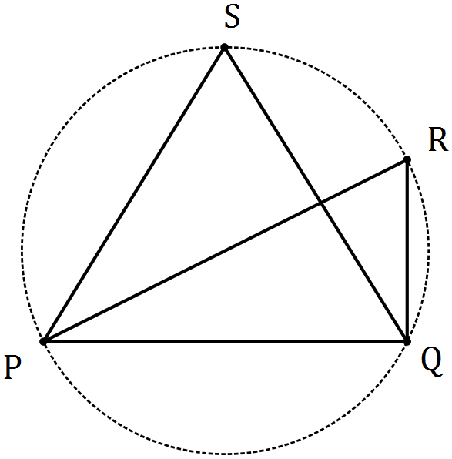

Determine the sizes of
Solution
$$∠PRQ=90-34=56°$$
$$∠PSQ=∠PRQ=56°$$

Specific behaviours
determines $∠PRQ$
states $∠PSQ$

(i) $∠PSQ$. (2 marks)

(ii) $∠RPS$. (2 marks)
Solution
$$∠SPQ=\frac{180-56}{2}=62°$$
$$∠RPS=62-34=28°$$

Specific behaviours
determines $∠SPQ$
determines $∠RPS$

(b) In the circle with centre $O$ drawn below, chord $AC$ intersects chord $BD$ at $E$. Explain, with reasoning, why triangles $AED$ and $BEC$ are similar. (3 marks)

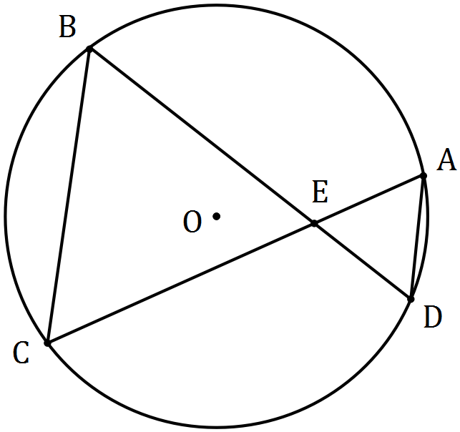
Solution
$∠AED=∠BEC$ (vertically opposite angles)
$∠CBD=∠CAD$ (angles stand on same arc)
Hence triangles are similar as three pairs of equal angles.

Specific behaviours
one pair of angles, with reason
second pair of angles, with reason
summary, using AAA reasoning

(c) Prove that when two chords of a circle intersect, the product of the lengths of the intervals on one chord equals the product of the lengths of the intervals on the other chord.
(3 marks)

Solution
Using diagram from (b), where $∆AED\sim ΔBEC$.

Then from ratio of corresponding sides $\frac{BE}{AE}=\frac{CE}{DE}$

Hence, $BE×DE=AE×CE$ and proof is complete.

Specific behaviours
uses diagram/similar triangles
uses ratio of sides
shows products are equal

Question 6 (9 marks)
(a) Determine the number of different four-letter passwords that can be made by arranging a selection of four letters chosen from the list P, Q, R, R, R, R and S. (4 marks)

Solution
In each case, ways to choose R's$×$ways to choose others$×$arrangements:
1 R: $1×1×4!=24$
2 R's: $1×3×\frac{4!}{2!}=36$
3 R's: $1×3×\frac{4!}{3!}=12$
4 R's: $1×1×1=1$
Number of different passwords is 73.

Specific behaviours
breaks in to cases
calculates one case correctly
calculates at least three cases correctly
correct total

(b) Determine the number of positive integers between 1 and 240 inclusive that are not divisible by at least one of the integers 4, 5 or 6. (5 marks)
Solution
Multiples of 4, 5 or 6: $\frac{240}{4}+\frac{240}{5}+\frac{240}{6}=60+48+40=148$

Multiples of 12, 20 or 30: $\frac{240}{12}+\frac{240}{20}+\frac{240}{30}=20+12+10+8=40$

Multiples of 60: $\frac{240}{60}=4$

Total divisible: $148-40+4=112$

Total not divisible: $240-112=128$

Specific behaviours
uses multiples of one, two and three numbers
uses LCM for two and three numbers
calculates at least one set of multiples correctly
uses inclusion-exclusion principle
correct answer

Additional working space

Question number: _________

© 2016 WA Exam Papers. Rossmoyne Senior High School has a non-exclusive licence to copy and communicate this paper for non-commercial, educational use within the school. No other copying, communication or use is permitted without the express written permission of WA Exam Papers. SN085-091-2.

