Copyright for test papers and marking guides remains with West Australian Test Papers.
Test papers may only be reproduced within the purchasing school according to the advertised Conditions of Sale.
Test papers should be withdrawn after use and stored securely in the school until Friday June 30th 2017.


MATHEMATICS
SPECIALIST
UNIT 1

Semester One

2017

SOLUTIONS
Calculator−free Solutions

1. (a) 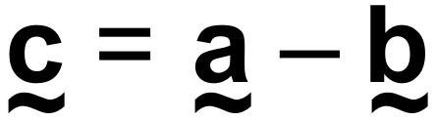 ✔
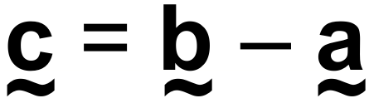 ✔
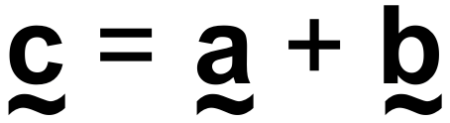 ✔

(b) 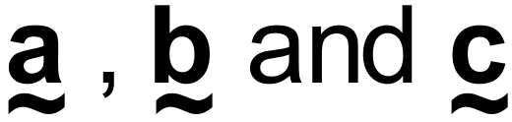 must form a closed loop, e.g.: ✔
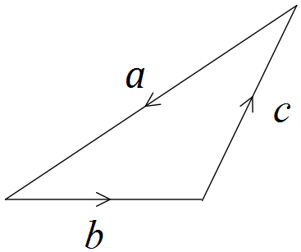

(c) III and IV ✔✔ [6]
2. (a) ✔
✔✔

(b) ✔
✔
✔

(c) 10 houses have married couples with children and pets,
therefore, 41 houses must be selected to obtain at least one
with both children and pets. ✔
The Pigeon Hole Principle. ✔ [8]

3. (a)
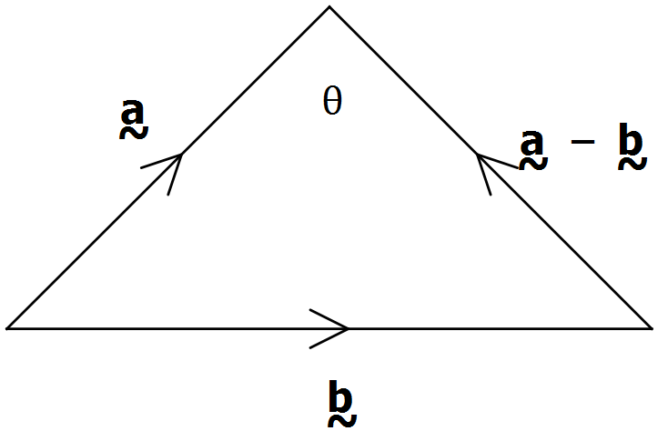
vector

location of

3. (b) ✔
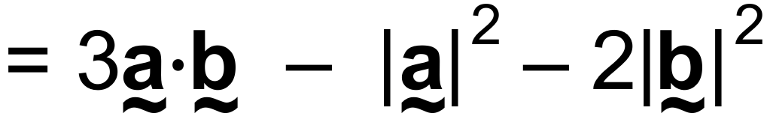 ✔
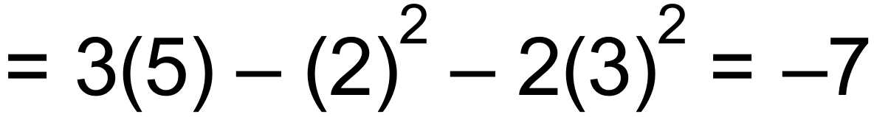 ✔ [5]

4. (a) (i) 20 ✔
(ii) 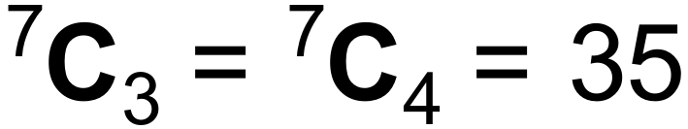 ✔

(b) (i) 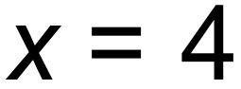; since 70 is in the 4th column of the 8th row ✔
(ii) 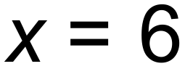; since 15 is in the 4th column of the 6th row ✔
(iii) 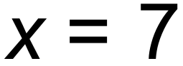; since in row 7, elements on columns 2 and 5 are equal ✔
(iv) ; since in row 8, elements on columns 2 and 6 are equal ✔

(c) (i) 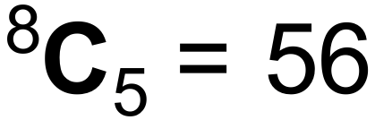 ✔
(ii) 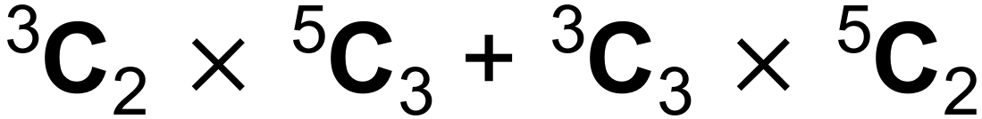 ✔✔
✔

(d) (i) 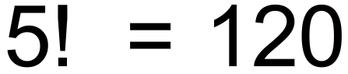 ✔
(ii) ✔
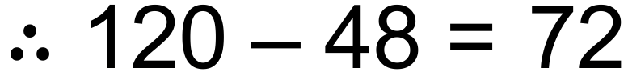 ✔ [13]

5. (a) 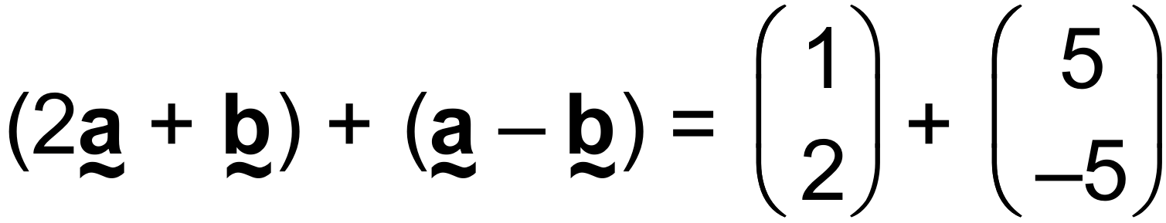
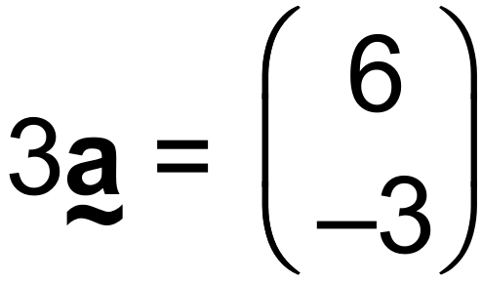 , hence 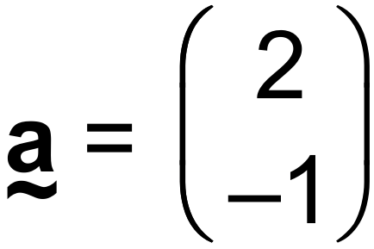 ✔✔
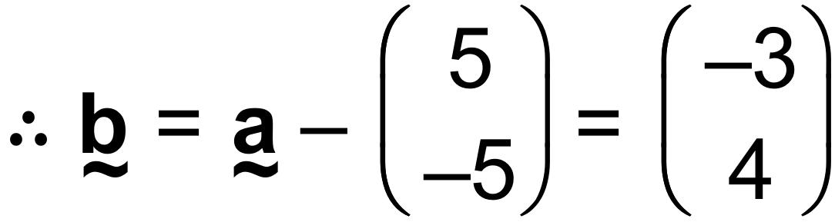 ✔
Hence, 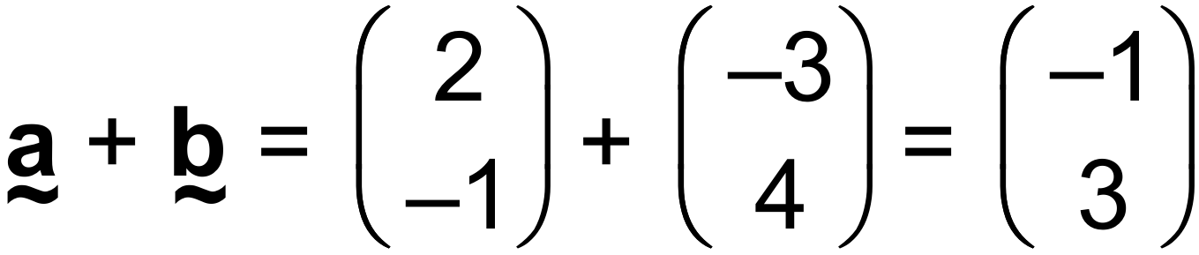 ✔
OR
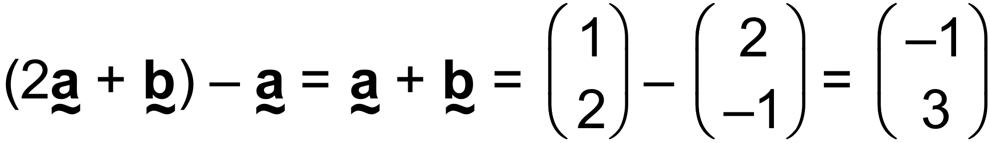 ✔✔

(b) 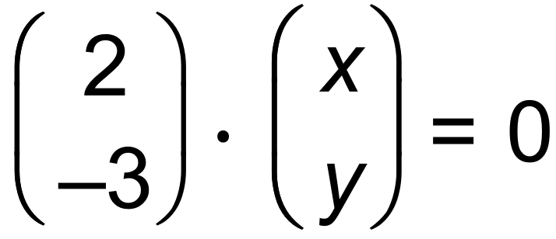 , hence 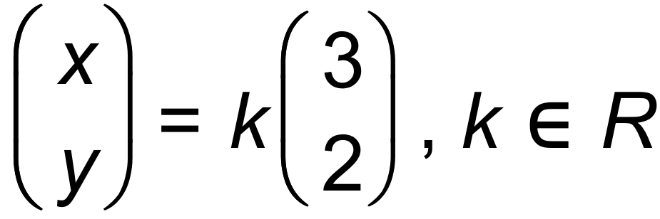 ✔
Unit vector 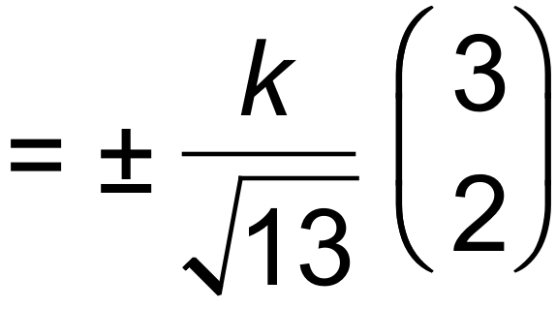 ✔ [6]

6. (a) 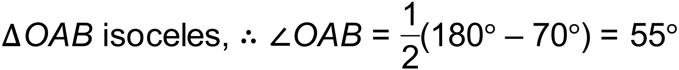 ✔
✔
✔

(b) 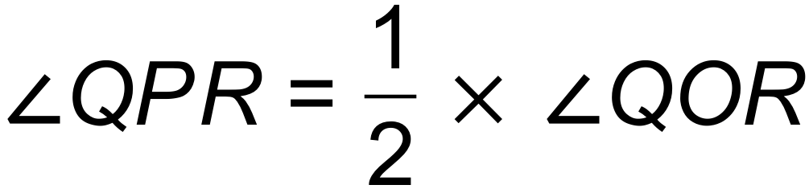 (angle at circumference is half angle at the centre) ✔
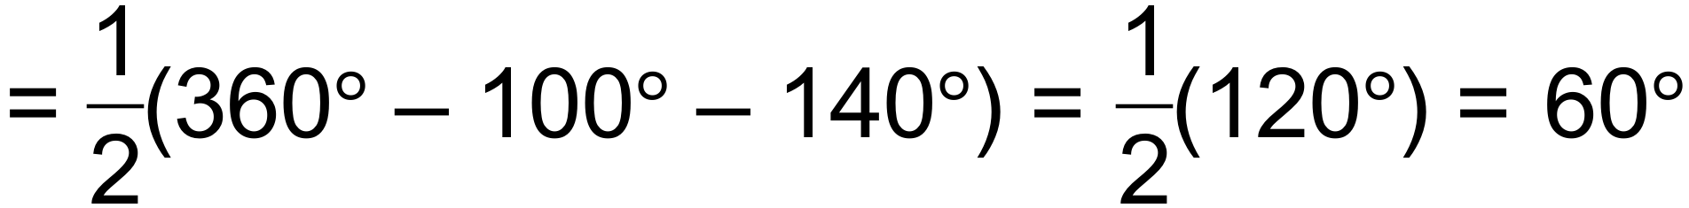 ✔

(c) 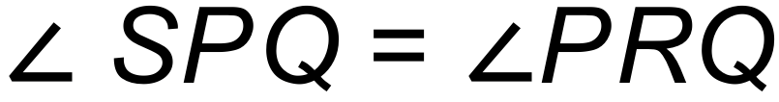 from the alternate-segment theorem ✔
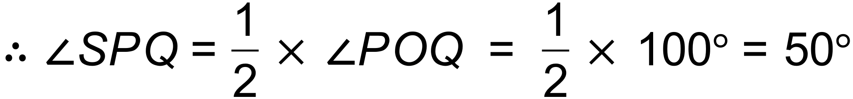 ✔ [7]

7. (a) 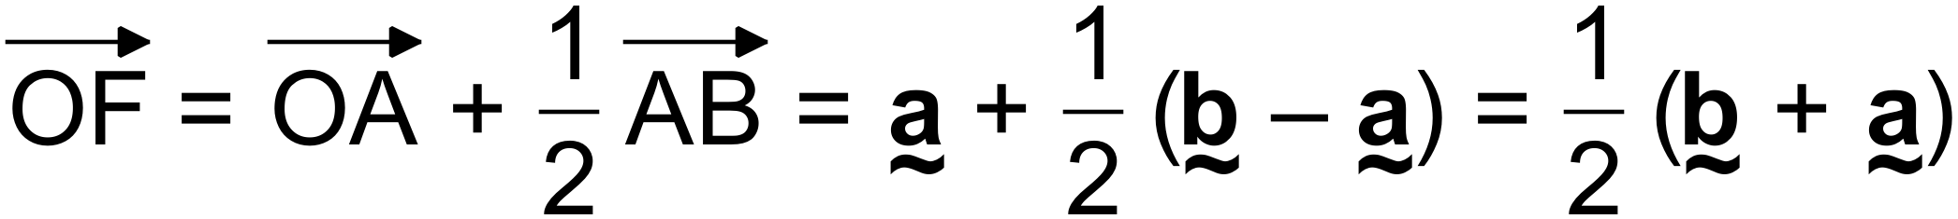 ✔
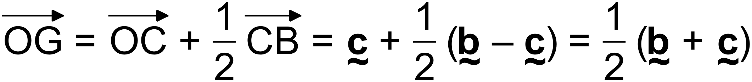 ✔

(b) Show that opposite sides are congruent and parallel:
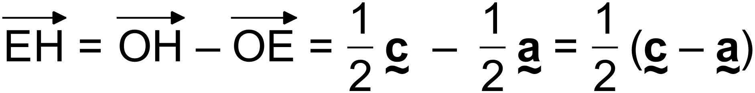 ✔
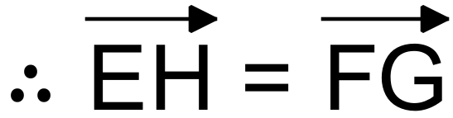 as required. ✔
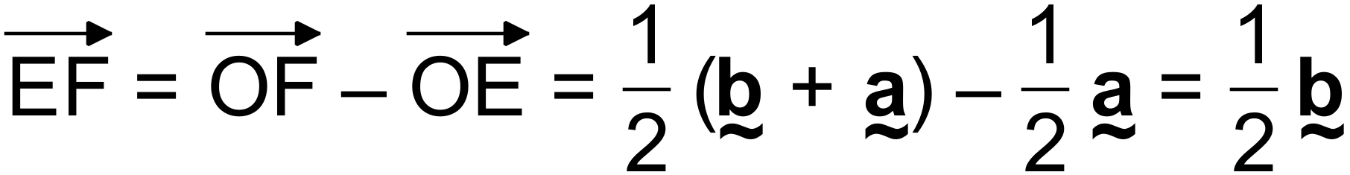
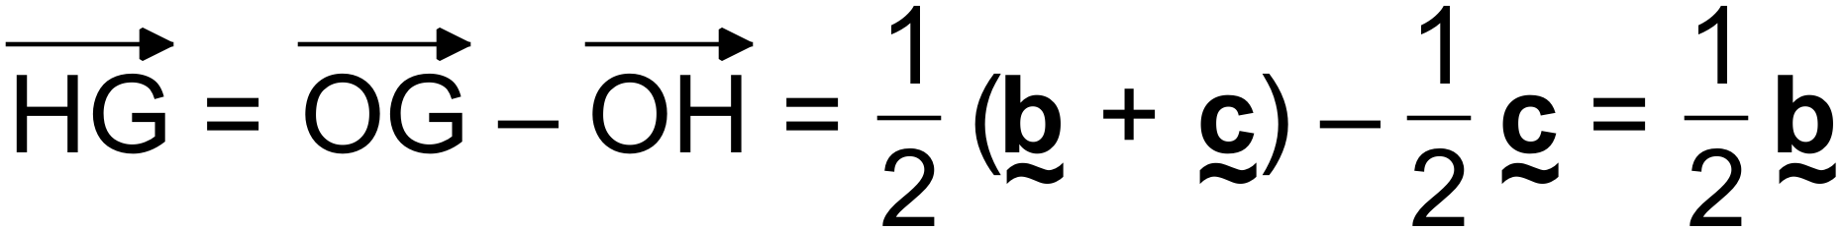
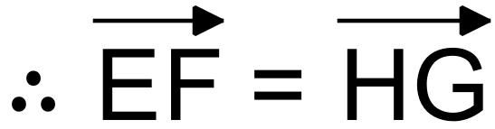 , and EFGH is a parallelogram ✔ [5]

Calculator−Assumed Solutions

8. 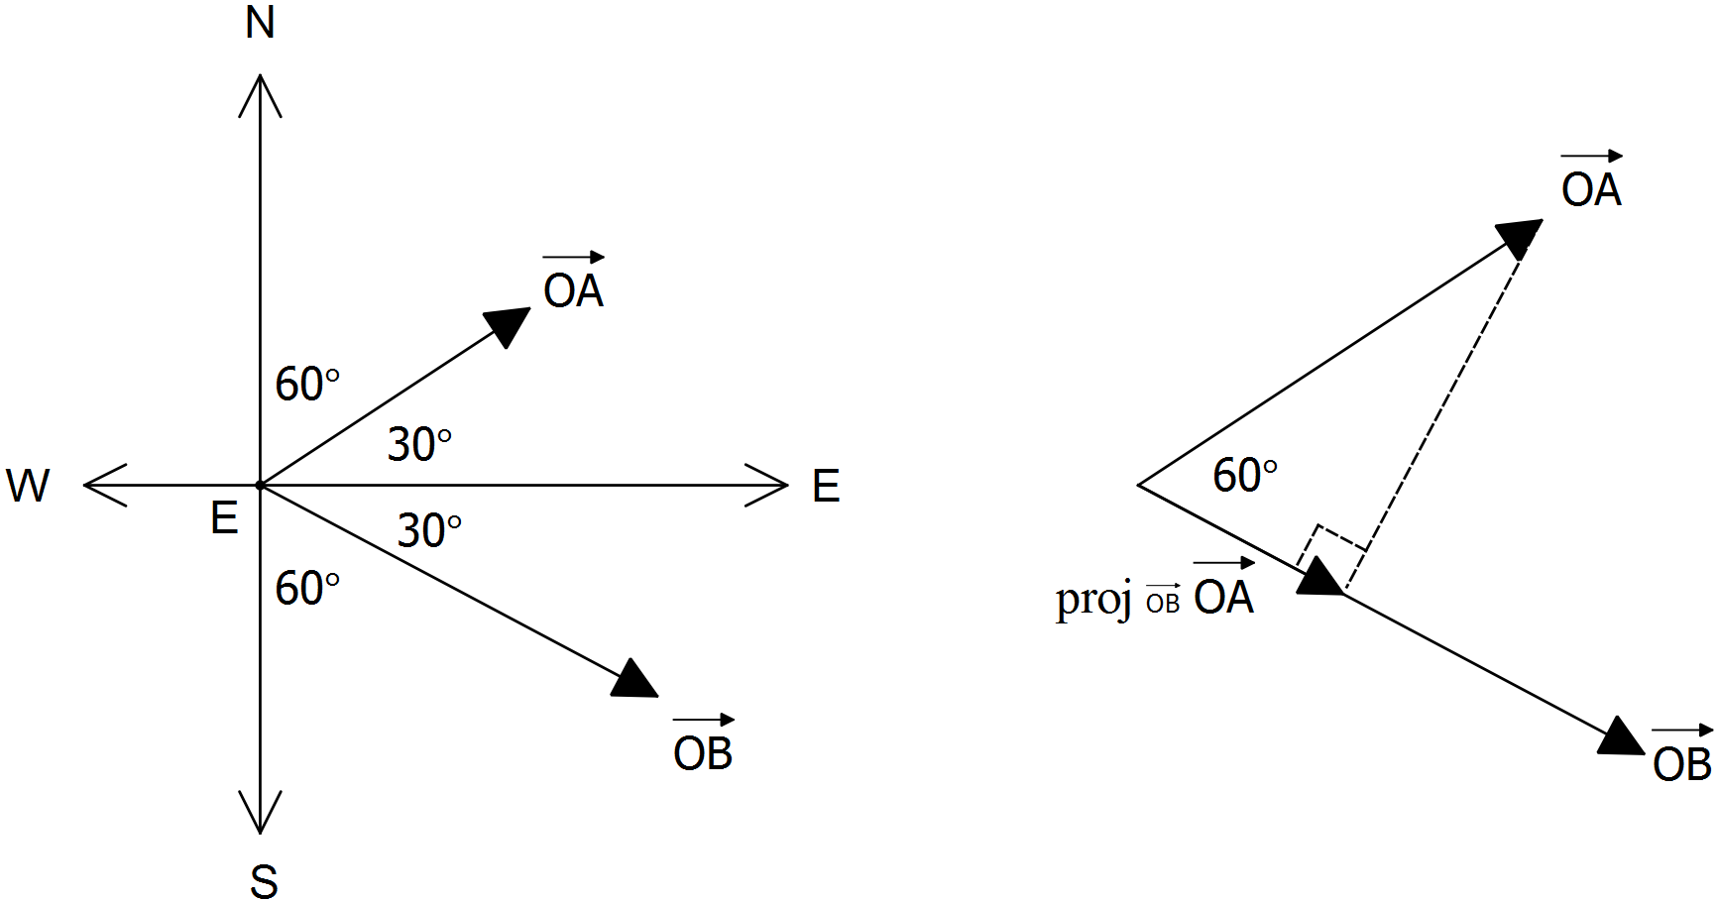

diagram(s)

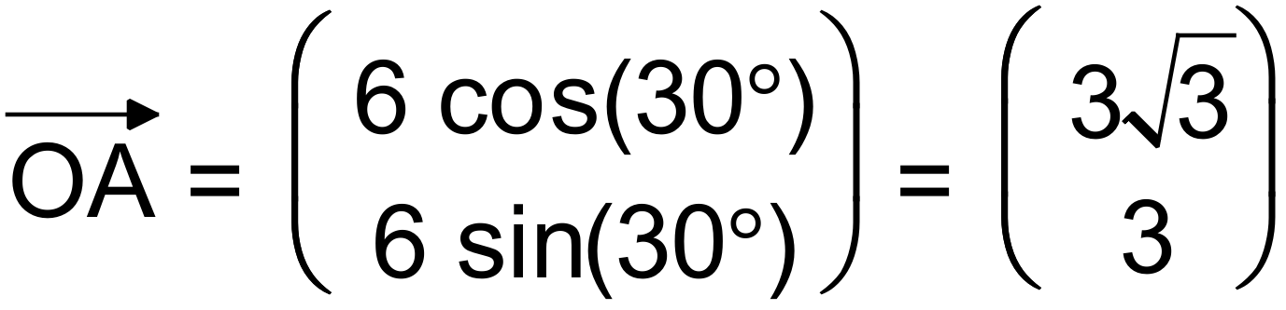 ✔
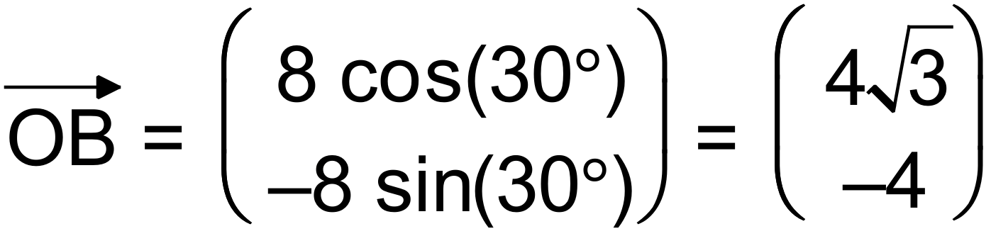 ✔
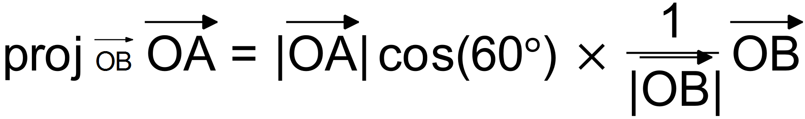 ✔
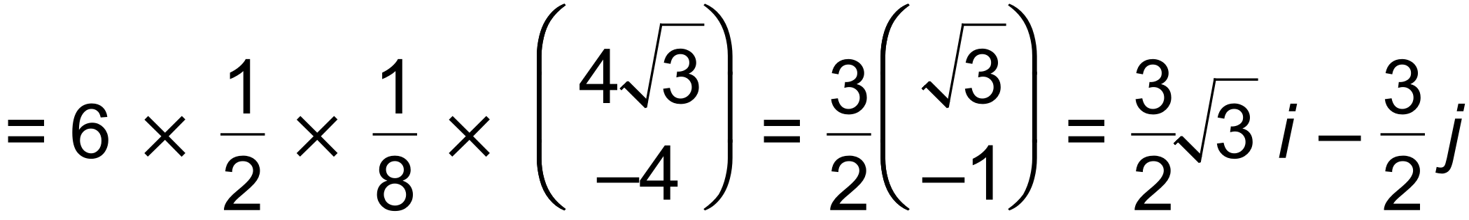 ✔ [5]

9. (a) 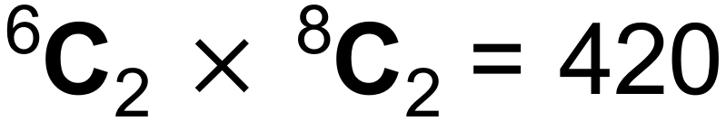 ✔✔
(b) (i) 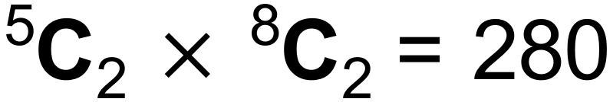 ✔✔
(ii) only choices are AB, DE, DF and EF ✔
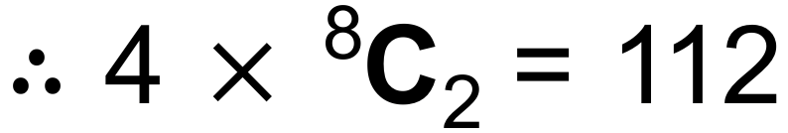 ✔✔ [7]

10. (a) LHS 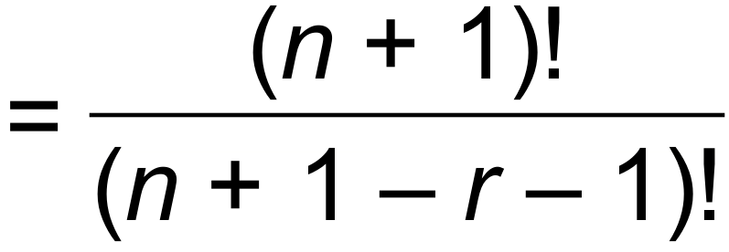 ✔
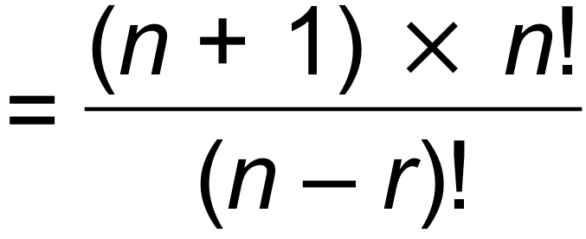 ✔
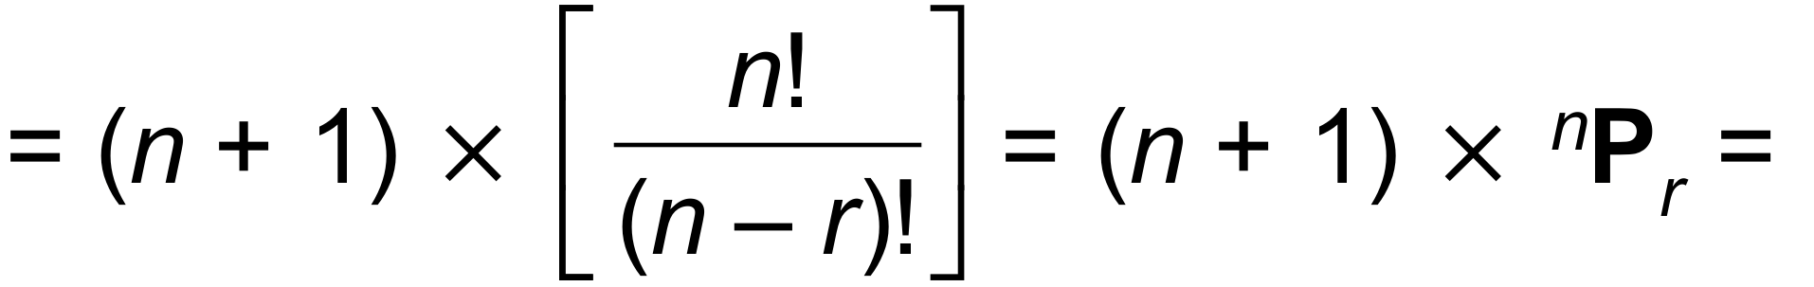 RHS ✔

(b) (i) 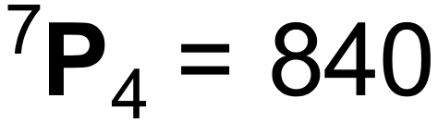 ✔
(ii) 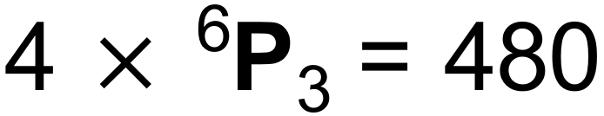 ✔✔
(iii) 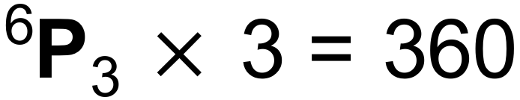 ✔✔ [8]

11. (a) 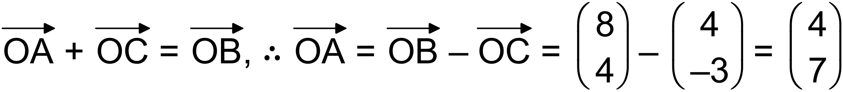 ✔
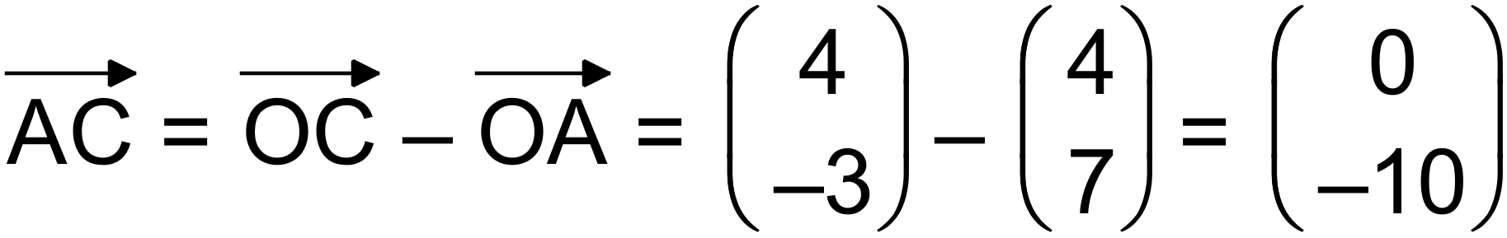 ✔

(b) 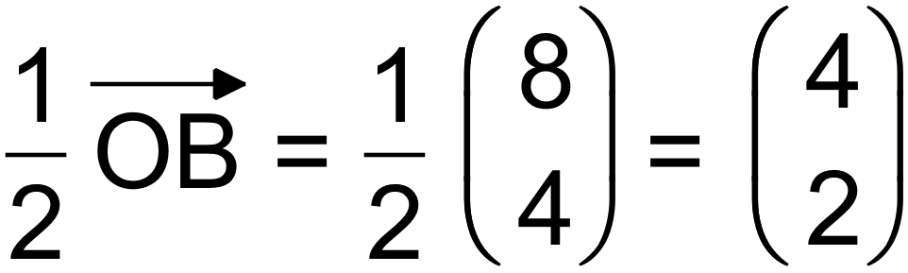 ✔
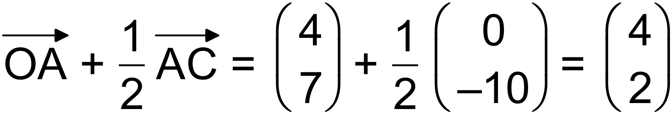 ✔✔
(4, 2) is the midpoint of both OB and AC ✔
Therefore, OB and AC bisect each other.

(c) 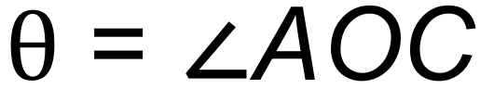 since OABC is a parallelogram
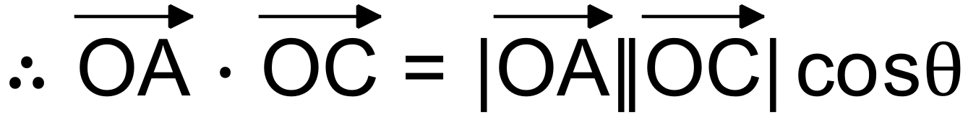
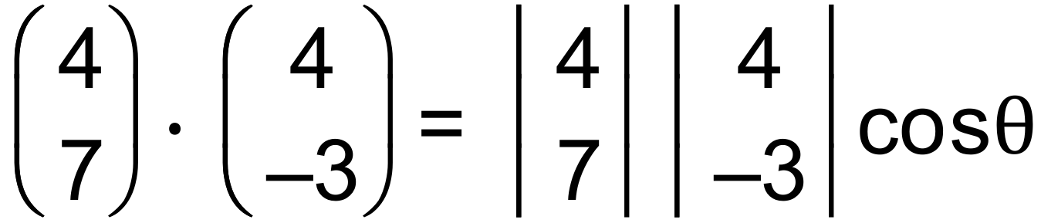 ✔
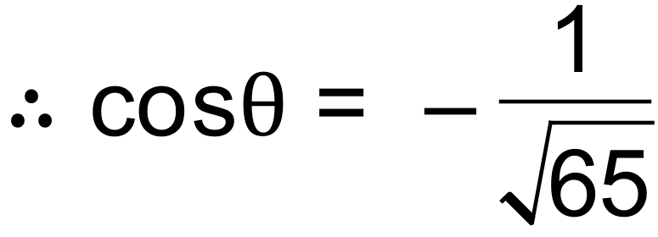 ✔
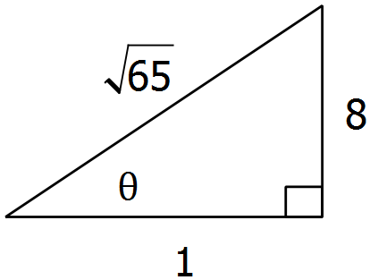
(d) From (c):

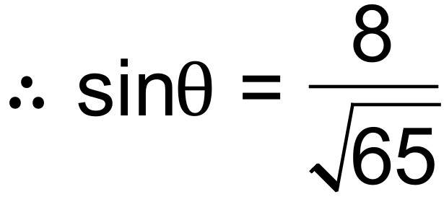 ✔

(e) Area OABC = 2 × Area ∆OAC
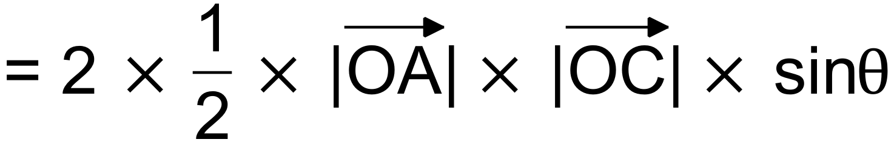
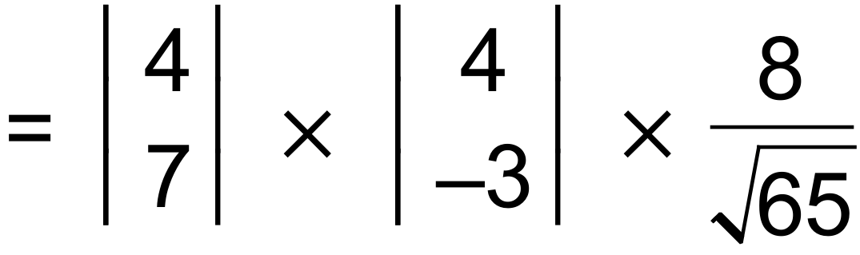 ✔
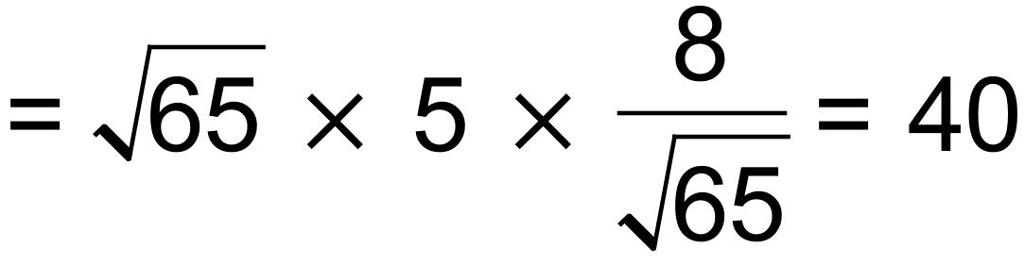 units² ✔ [11]

12. (a) (i) For all natural/counting numbers represented by n ✔
there exists another natural number m ✔
such that n is the square of m
OR such that m is a whole number root of n. ✔

12. (a) (ii) 5 is natural and there is no natural number that
when squared gives 5.
(any acceptable answer) ✔

(b) A rhombus has two pairs of parallel sides,
therefore B $⇒$ A is a valid statement. ✔
Not all parallelograms are rhombi, e.g. rectangles,
therefore A $⇒$ B is not a valid statement. ✔
Hence, A is not equivalent to B, i.e. A $⇔$ B is invalid. ✔

(c) (i) If a triangle inscribed in a circle is right angled, then
the triangle has the diameter as one of its sides. ✔

(ii) Yes, because ALL right-angled triangles inscribed
in a circle will have the diameter as the hypotenuse. ✔

(iii) If a triangle inscribed in a circle does not have the
diameter as one of its sides, then the triangle is not
right angled. ✔

(iv) Yes, because if a statement is true then so is the
contrapositive of that statement ✔ [11]

13. (a) 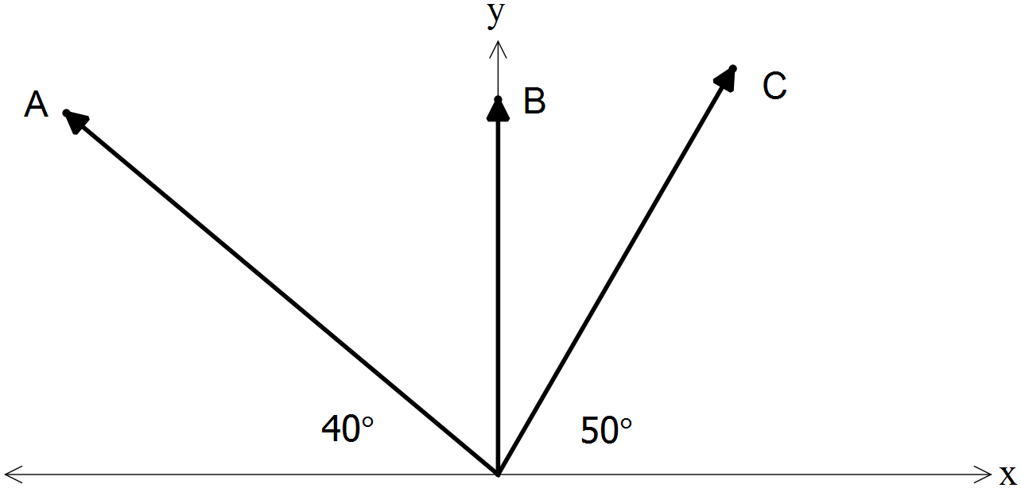

Combined force vector: 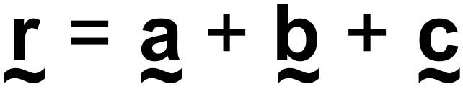
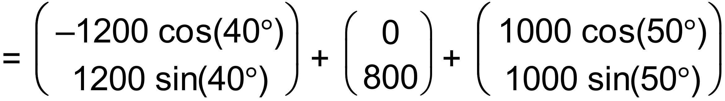 ✔✔✔
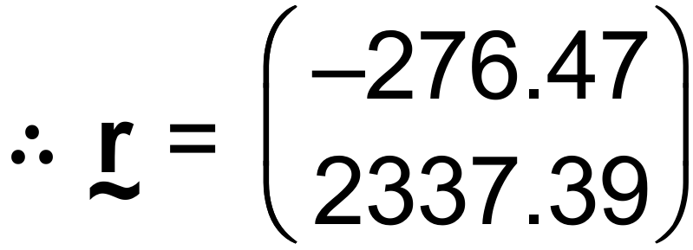 ✔
and  ✔
bearing = 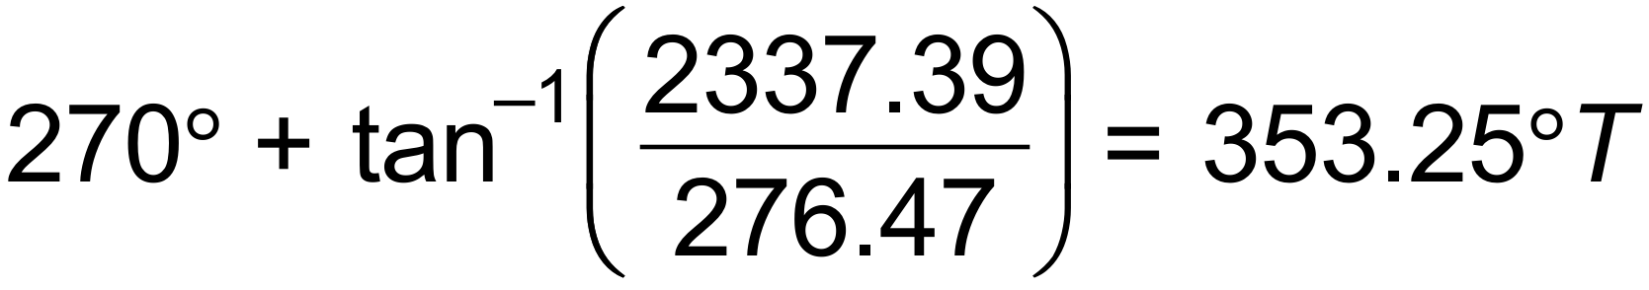 ✔

13. (b) 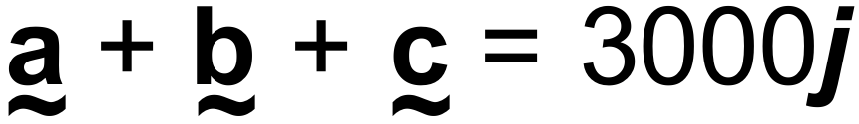 ✔
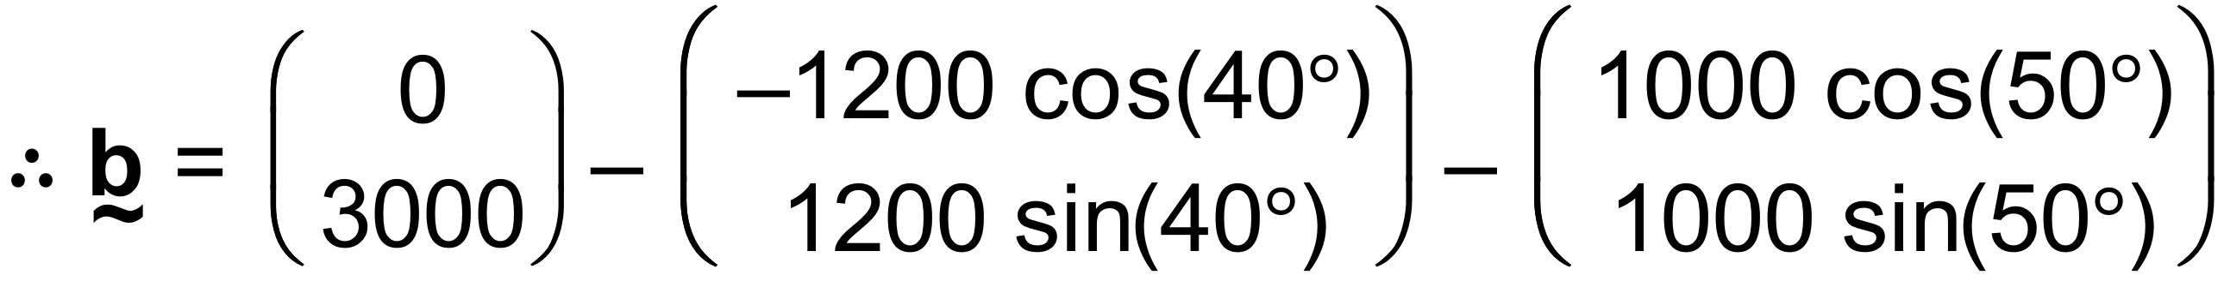
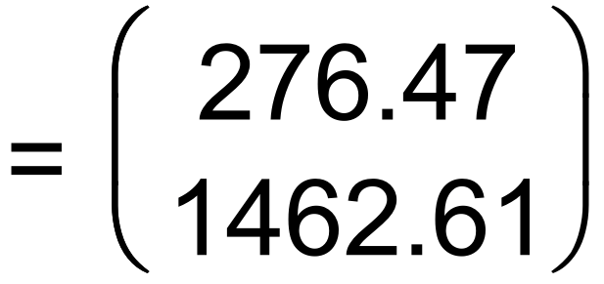 ✔
maximum force = 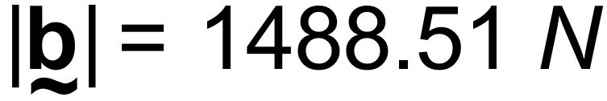 ✔
bearing = 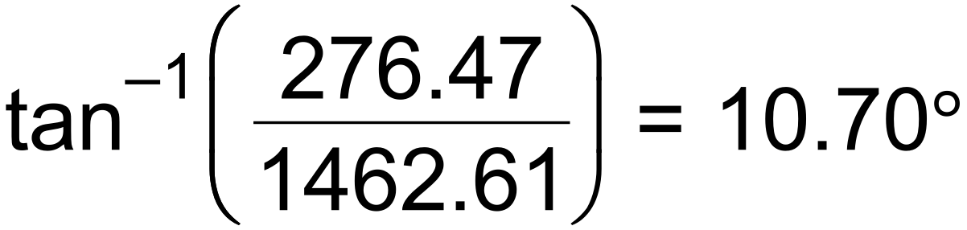
∴ 79.30°T ✔ [10]

14. (a) Assume that n is even and 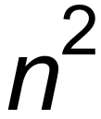 is odd. ✔
Then 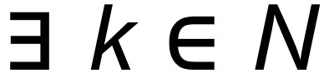 such that 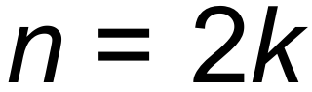 ✔
Thus, 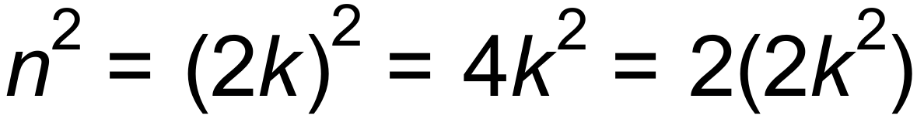
which implies that must be even. ✔
Since cannot be both even and odd, this is a contradiction ✔
and therefore n must be even.

(b) ✔
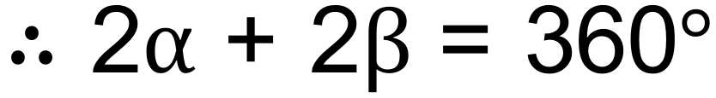 ✔
and hence 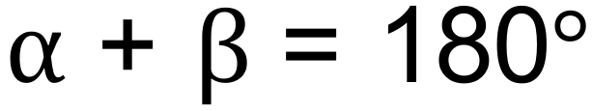 as required ✔
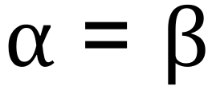 if O,B,D are collinear OR DB=diameter ✔ [8]

15. (a) 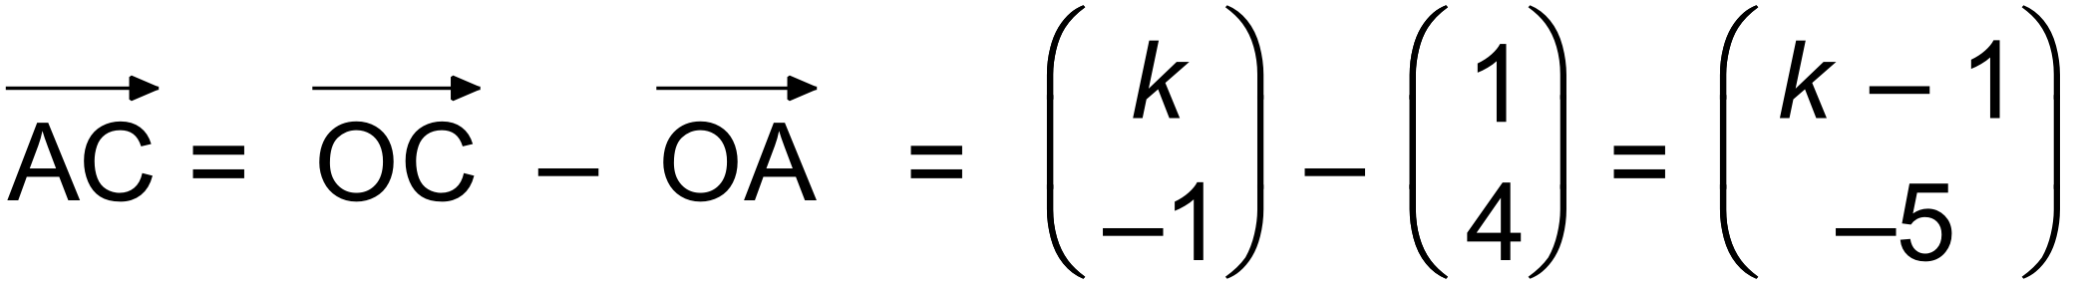 ✔
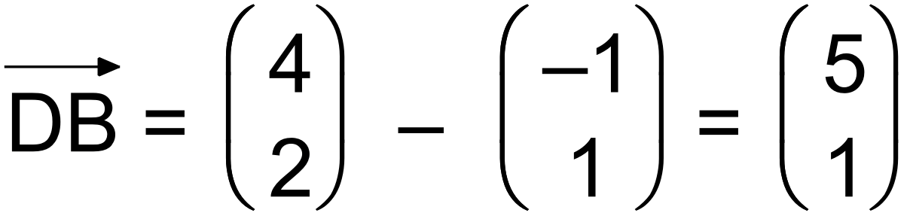 ✔

(b) In a rhombus the diagonals are perpendicular.
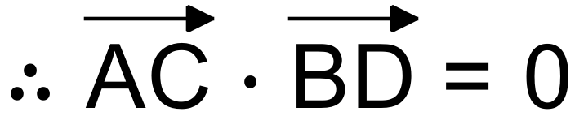 ✔
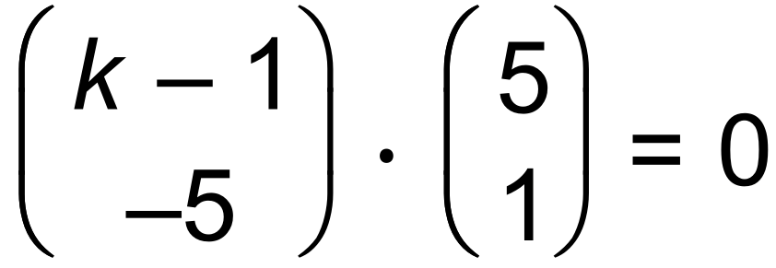 hence 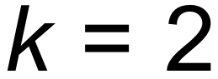 ✔

(c) 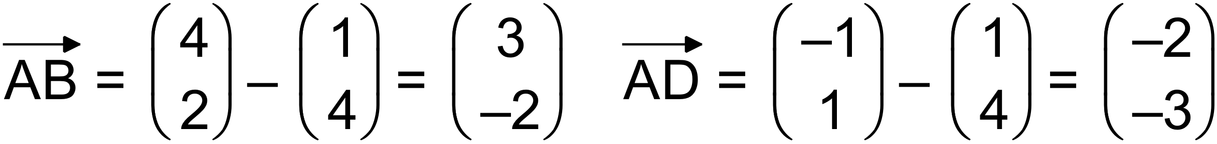 ✔
✔
✔
as required. [7]
16. (a) 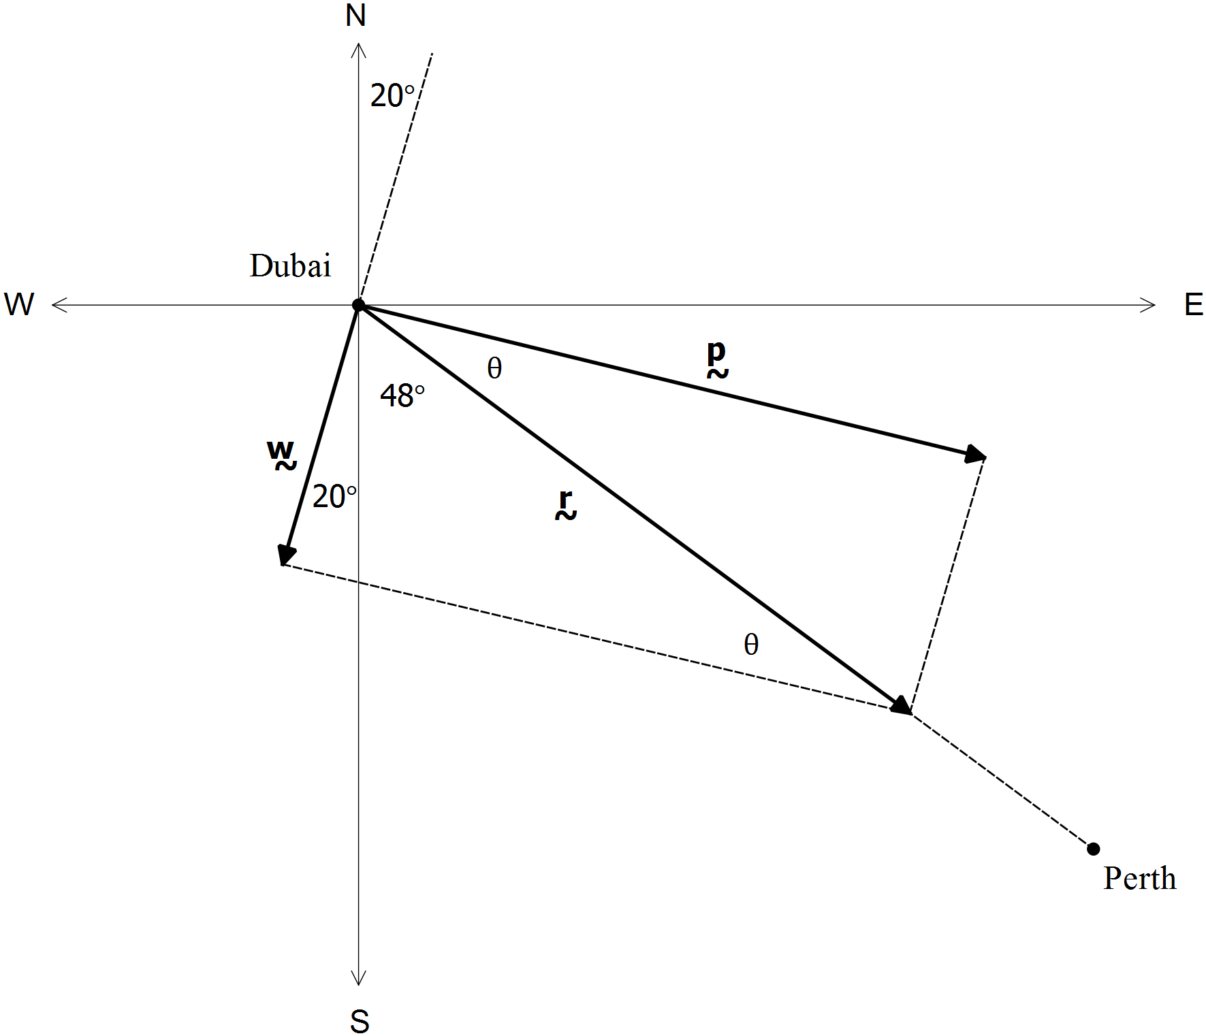

wind vector
plane vector
flight direction
and resultant
vector using
parallelogram
method

(b) 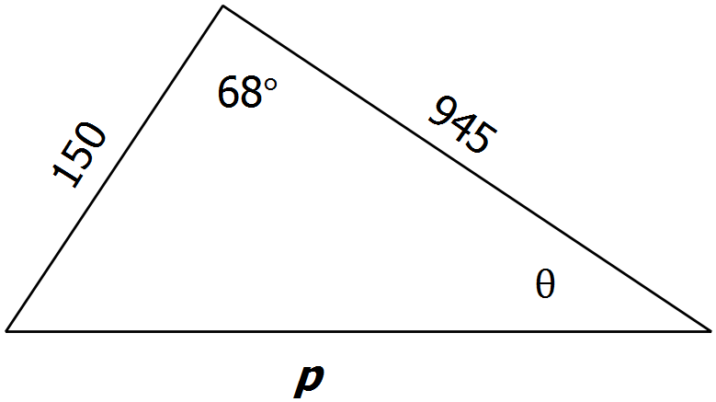
68° angle
between wind
and plane
speeds

(c) ✔
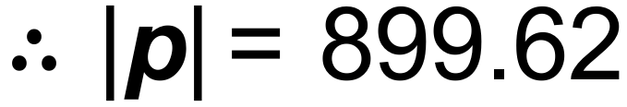 km/h ✔

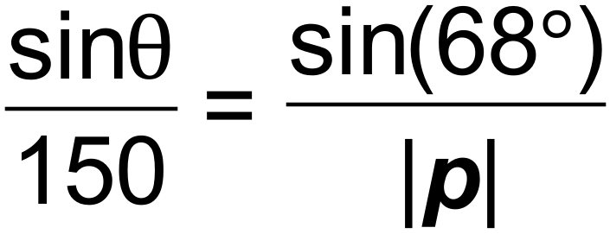 ✔
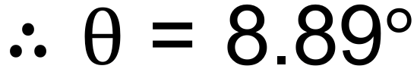 ✔

Hence, bearing = 132°– 8.89° = 123.11°T ✔
and flight duration = 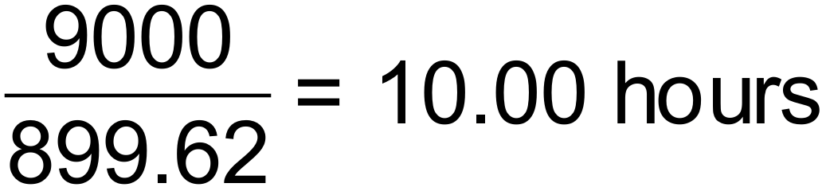 ✔ [11]

17. 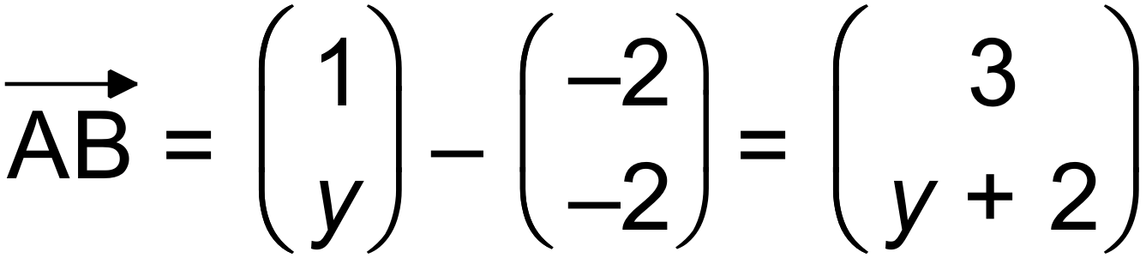 ✔
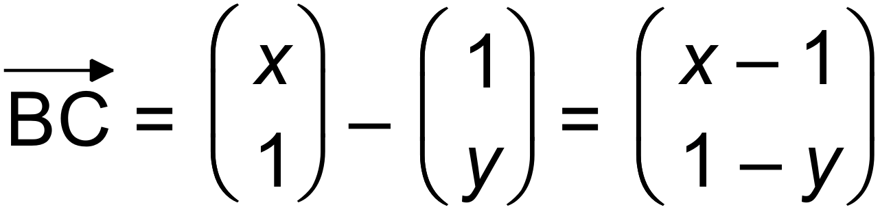 ✔

since A,B,C collinear then 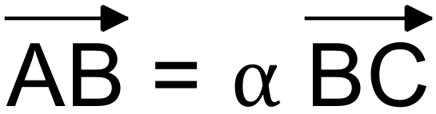 ✔
Given AB:BC = 1:2 then 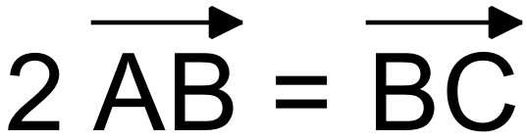 ✔

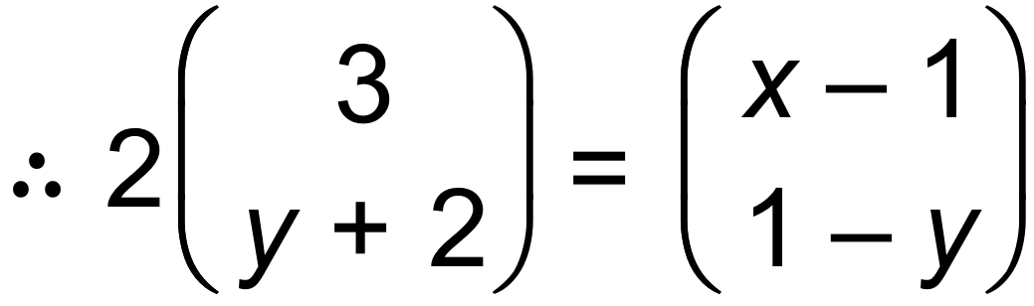
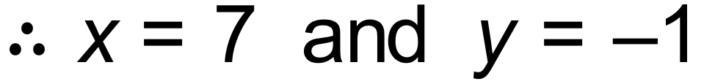 ✔✔ [6]

18. (a) 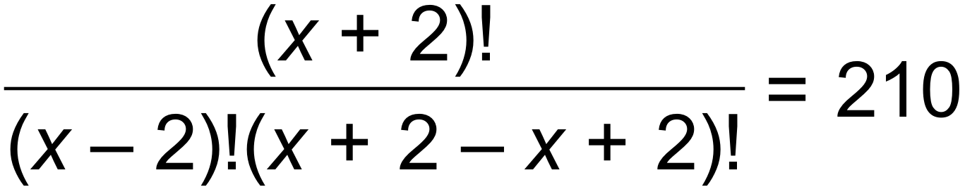 ✔
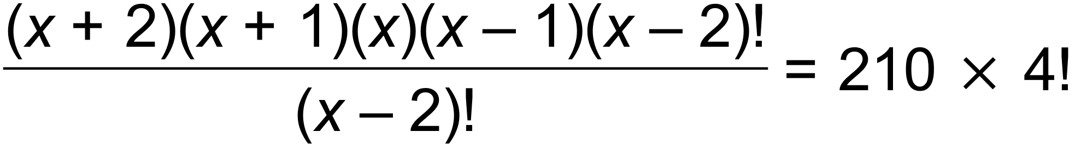 ✔
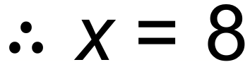 ✔

(b) LHS 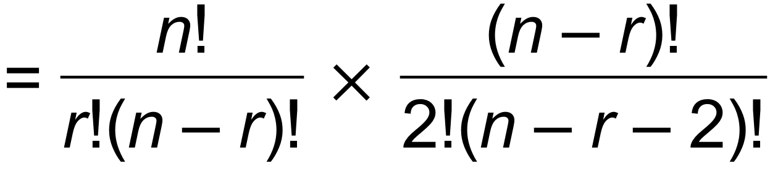 ✔
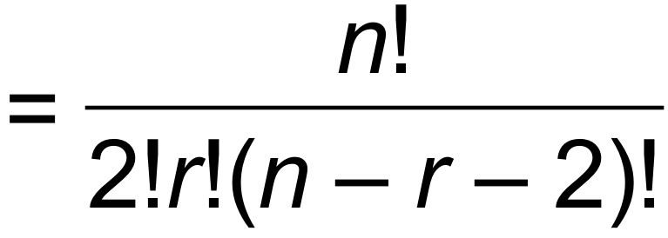 ✔
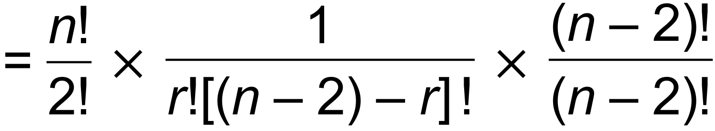 ✔
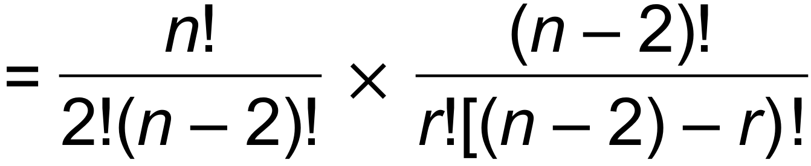 ✔
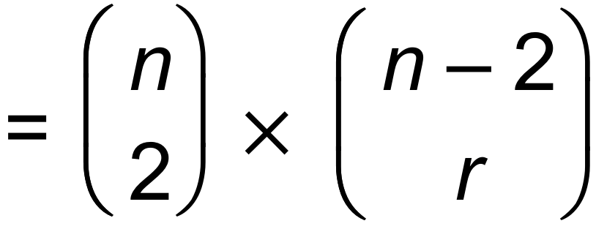 = RHS [7]

19. (a) Let  and 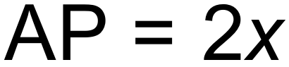

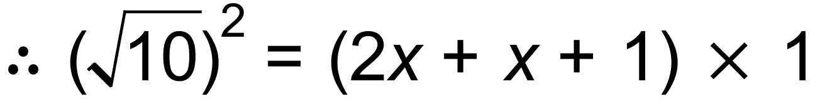 ✔
 ✔
and hence  ✔

(b)
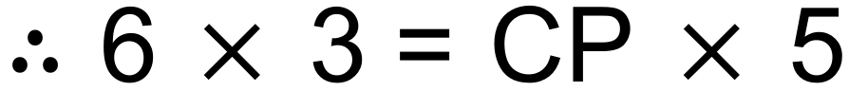 ✔
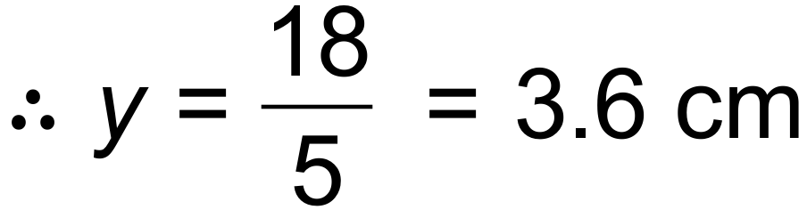 ✔
and hence  ✔

(c) ∆PBD is right angled since ∆ABD is right angled (triangle in semicircle)
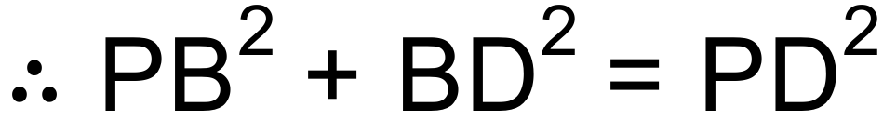
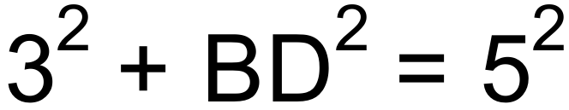
 ✔

(d) ∆ABD is right angled in semicircle
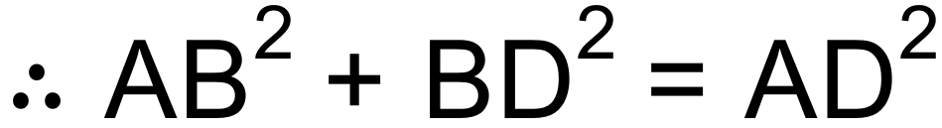 ✔
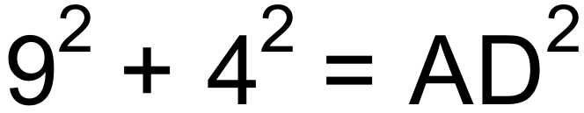
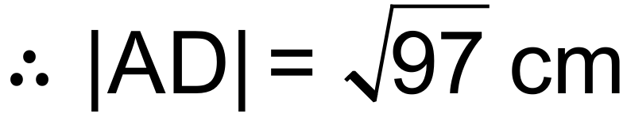
hence, radius is 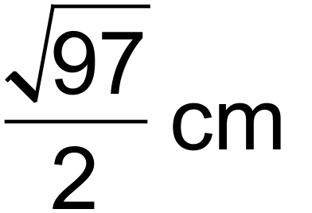 ✔ [9]

